Claim No. F8GF0H8T

Exhibits for Daniel Cheung (Defendant) for Claim no. F8GF0H8T in the County Court at Milton Keynes

Page 1 - Contents
Page 2 - DH/01: Parking Sign upon parking my car
Page 3 - DH/02: Picture of vehicle in front of parking sign
Page 4 - DH/03: Image of car park entrance sign
Page 5 - DH/04: Image of car park entrance
Page 6 - DH/05: Google image of Car park entrance
Page 7 - DH/05: Google image of Car park entrance from a different angle
Page 8 - DH/06: Schedule of Costs

DH/01 Claim No. F8GF0H8T

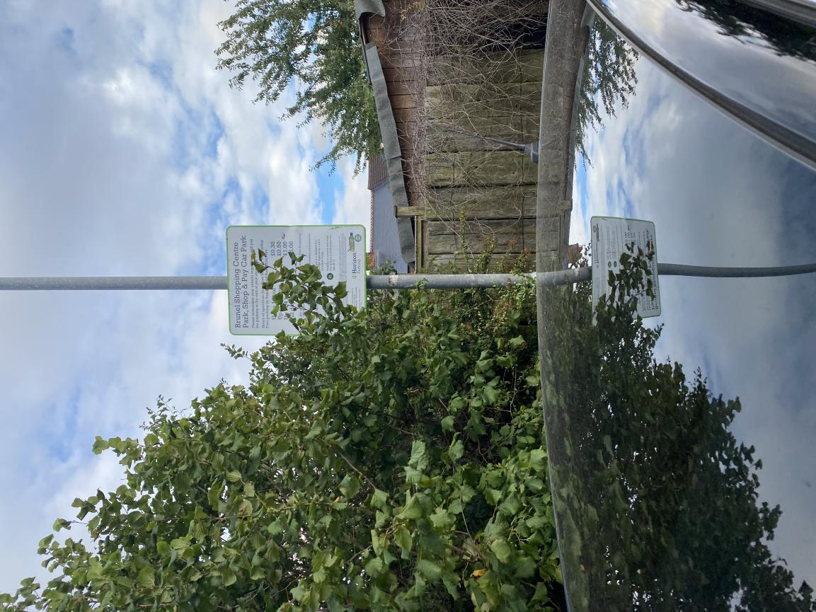

DH/02 Claim No. F8GF0H8T

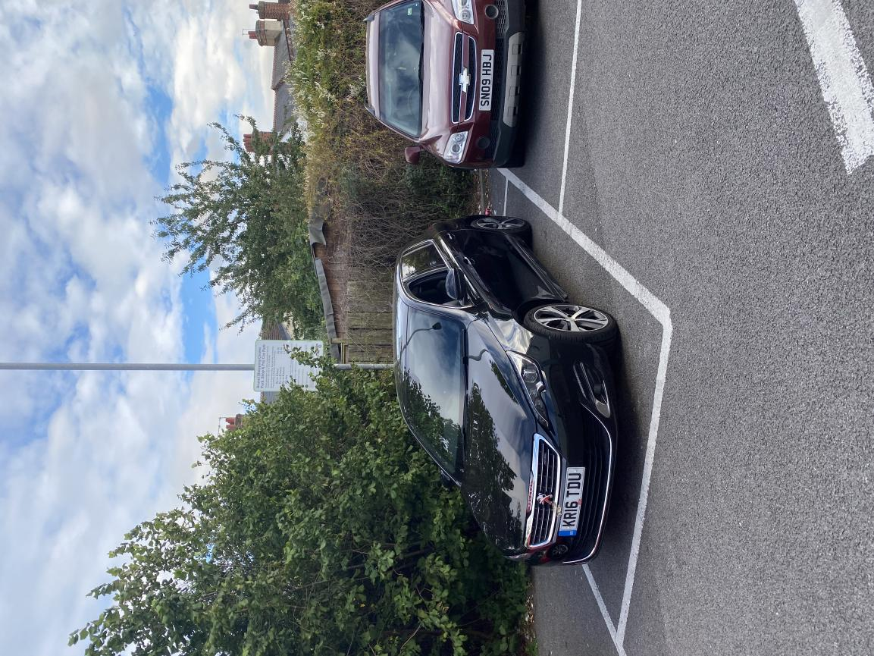

DH/03 Claim No. F8GF0H8T

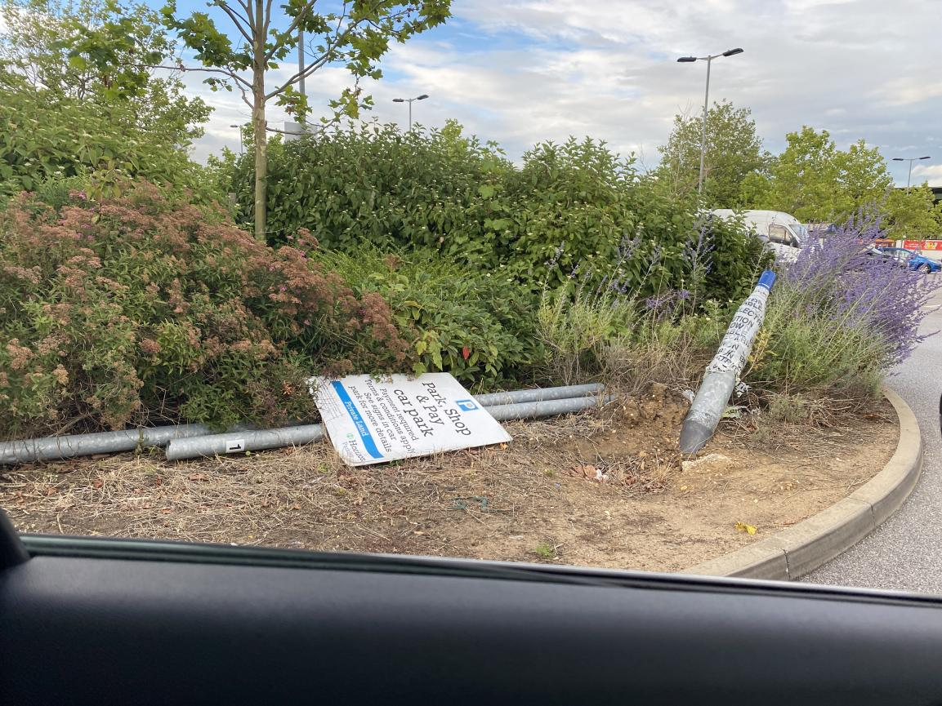

DH/04 Claim No. F8GF0H8T

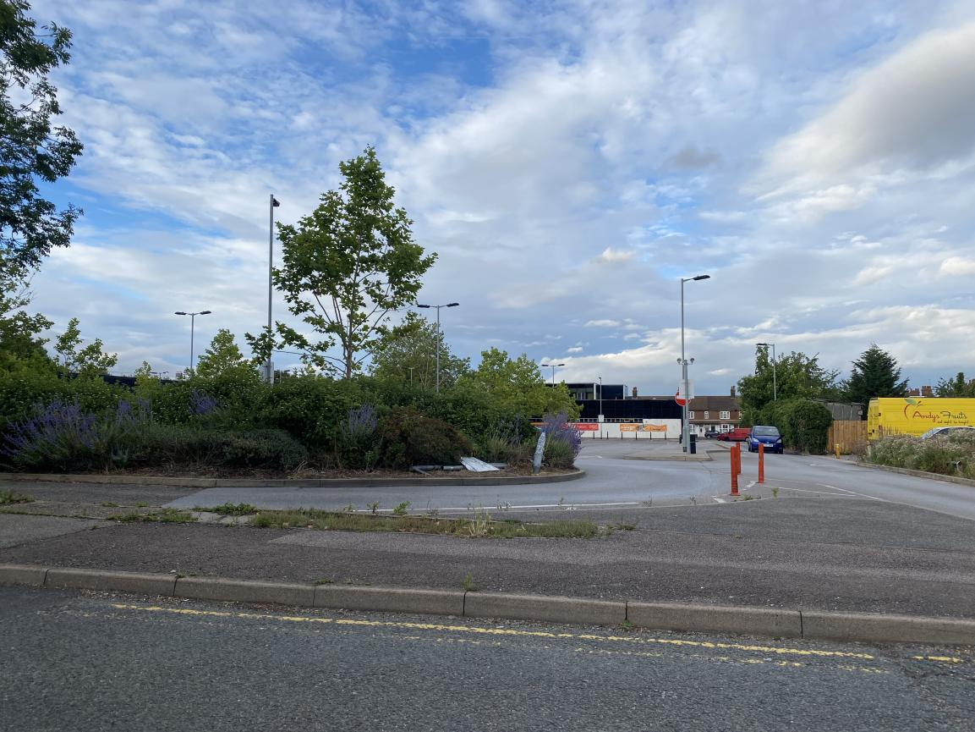

DH/05 Claim No. F8GF0H8T

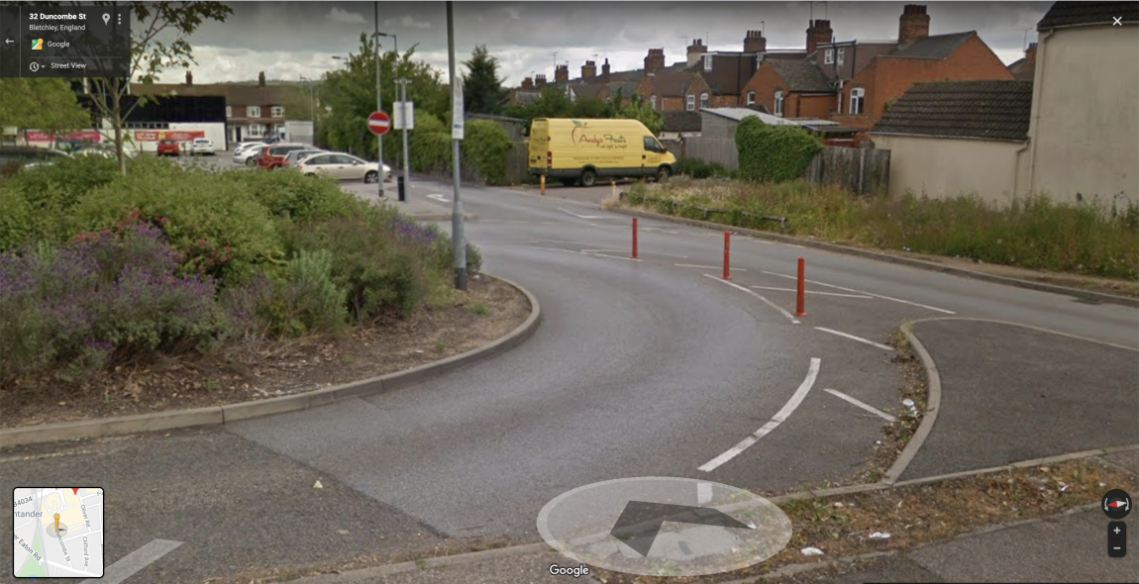

DH/05 Claim No. F8GF0H8T

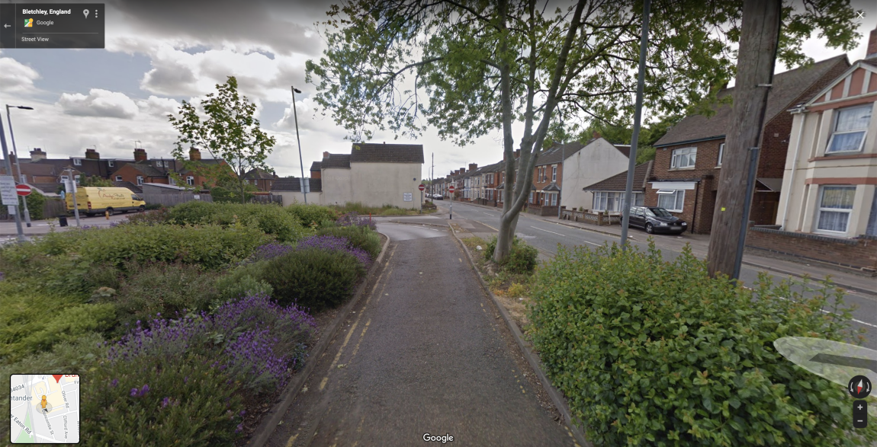

DH/06 Claim No. F8GF0H8T

In the County Court at Milton Keynes
Claim number: F8GF0H8T
Hearing Date: 04/08/2020

DEFENDANT’S SCHEDULE OF COSTS

Ordinary Costs

Loss of earnings/leave, incurred through attendance at Court (over the phone) 04/08/2020 £60

Sub-total £60

Further costs for Claimant’s unreasonable behaviour, pursuant to Civil Procedure Rule 27.14(2)(g)

Research, preperation and drafting of documents (16 hours at Litigant in Person rate of £19 per hour) £304

Stationary, printing, photocopying and postage £24

Sub-total £328

£ TOTAL COSTS CLAIMED £ 388

Signed

[To print and sign]

23/07/2020

