Appeal re POPLA Code: ……………………….

Vehicle Registration: ……………….
POPLA ref: …………….
I, the registered keeper of this vehicle was made aware of being issued Parking Charge notice but, did not receive a letter acting as a notice to the registered keeper. My appeal to the operator ––……………….. was submitted and acknowledged on but subsequently rejected by a letter attachment to an email dated …………….. I contend that I, as the keeper, am not liable for the alleged parking charge and wish to appeal against it on the following grounds:
No keeper liability - PoFA non-compliant NTK due to failure to adhere to strict wording and guidelines set out in PoFA –
The operator has not shown that the individual who it is pursuing is in fact the driver who may have been potentially liable for the charge.
A compliant Notice to Keeper was never served - no Keeper Liability can apply.
There are no easily visible entrance signs for the regular entry and the signs in this car park are not prominent, clear or legible from all parking spaces and there is insufficient notice of the sum of the parking charge itself
No Evidence of Landowner Authority - the operator is put to strict proof of full compliance with the BPA Code of Practice
No contract offered as parking is prohibited if the makings aren't clear, that would make the signage forbidding and incapable of forming a contract. (will add something later)
Unclear signage As for the signs saying that parking is prohibited if the makings aren't clear, that would make the signage forbidding and incapable of forming a contract. There is no consideration (no offer to park).
Please note: Additional larger copies of photographic evidence are provided at the back of
this document for reference, as well as embedded within the document where relevant.
Photographic evidence attached at the end of this document.
No keeper liability - PoFA non-compliant NTK due to failure to adhere to strict wording and guidelines set out in PoFA – no NTK issued
Under schedule 4, paragraph 4 of the POFA, an operator can only establish the right to recover any unpaid parking charges from the keeper of a vehicle if certain conditions must be met as stated in paragraphs 5, 6, 11, and 12. National Car Parks Limited have failed to fulfil the conditions which state that an operator must have provided the keeper with a Notice to Keeper (NTK) in accordance with paragraph 9, which stipulates as mandatory, a set timeline and wording:-Paragraph 9 (2)(f) states:
“The notice must-
(f) Warn the keeper that if, after the period of 28 days beginning with the day after that on which the notice is given—
i) the amount of the unpaid parking charges specified under paragraph (d) has not been paid in full, and
ii)the creditor does not know both the name of the driver and a current address for service for the driver, the creditor will (if all the applicable conditions under this Schedule are met) have the right to recover from the keeper so much of that amount as remains unpaid;
The NTK is not compliant with the specific wording and information which must be provided to the keeper as per PoFA Schedule 4 paragraph 9. Lack of NTK issued to me as keeper of a vehicle does not give warning to me as the keeper that ……………….. ……….. have a right to recover costs from myself as keeper.

The operator has not shown that the individual who it is pursuing is in fact the driver who may have been potentially liable for the charge.
In cases with a keeper appellant, yet no POFA 'keeper liability' to rely upon, POPLA must first consider whether they are confident that the Assessor knows who the driver is, based on the evidence received. No presumption can be made about liability whatsoever. A vehicle can be driven by any person (with the consent of the owner) as long as the driver is insured. There is no dispute that the driver was entitled to drive the car and I can confirm that they were, but I am exercising my right not to name that person.
In this case, no other party apart from an evidenced driver can be told to pay. As there has been no admission regarding who was driving, and no evidence has been produced, it has been held by POPLA on numerous occasions, that a parking charge cannot be enforced against a keeper without a valid NTK.
As the keeper of the vehicle, it is my right to choose not to name the driver, yet still not be lawfully held liable if an operator is not using or complying with Schedule 4. This applies regardless of when the first appeal was made and regardless of whether a purported 'NTK' was served or not, because the fact remains I am only appealing as the keeper and ONLY Schedule 4 of the POFA (or evidence of who was driving) can cause a keeper appellant to be deemed to be the liable party.
The burden of proof rests with the Operator to show that (as an individual) I have personally not complied with terms in place on the land and show that I am personally liable for their parking charge. They cannot.
Furthermore, the vital matter of full compliance with the POFA was confirmed by parking law expert barrister, Henry Greenslade, the previous POPLA Lead Adjudicator, in 2015:
Understanding keeper liability
'There appears to be continuing misunderstanding about Schedule 4. Provided certain conditions are strictly complied with, it provides for recovery of unpaid parking charges from the keeper of the vehicle.
There is no 'reasonable presumption' in law that the registered keeper of a vehicle is the driver. Operators should never suggest anything of the sort. Further, a failure by the recipient of a notice issued under Schedule 4 to name the driver, does not of itself mean that the recipient has accepted that they were the driver at the material time.
Unlike, for example, a Notice of Intended Prosecution where details of the driver of a vehicle must be supplied when requested by the police, pursuant to Section 172 of the Road Traffic Act 1988, a keeper sent a Schedule 4 notice has no legal obligation to name the driver. [...] If {POFA 2012 Schedule 4 is} not complied with then keeper liability does not generally pass.'
Therefore, no lawful right exists to pursue unpaid parking charges from myself as keeper of the vehicle, where an operator cannot transfer the liability for the charge using the POFA.
This exact finding was made in 6061796103 against ParkingEye in September 2016, where POPLA Assessor Carly Law found:
''I note the operator advises that it is not attempting to transfer the liability for the charge using the Protection of Freedoms Act 2012 and so in mind, the operator continues to hold the driver responsible. As such, I must first consider whether I am confident that I know who the driver is, based on the evidence received. After considering the evidence, I am unable to confirm that the appellant is in fact the driver. As such, I must allow the appeal on the basis that the operator has failed to demonstrate that the appellant is the driver and therefore liable for the charge. As I am allowing the appeal on this basis, I do not need to consider the other grounds of appeal raised by the appellant. Accordingly, I must allow this appeal.''

A compliant Notice to Keeper was never served - no Keeper Liability can apply.
This operator has not fulfilled the 'second condition' for keeper liability as defined in Schedule 4 and as a result, they have no lawful authority to pursue any parking charge from myself, as a registered keeper appellant. There is no discretion on this matter. If Schedule 4 mandatory documents are not served at all, or in time (or if the document omits any prescribed wording) then keeper liability simply does not apply.
The wording in the Protection of Freedoms Act (POFA) 2012 is as follows:
''Right to claim unpaid parking charges from keeper of vehicle:
4(1) The creditor has the right to recover any unpaid parking charges from the keeper of the vehicle. (2) The right under this paragraph applies only if
(a) the conditions specified in paragraphs 5, 6*, 11 and 12 (so far as applicable) are met;
*Conditions that must be met for purposes of paragraph 4:
6(1) 'The second condition is that the creditor (or a person acting for or on behalf of the creditor) - (a)has given a notice to driver in accordance with paragraph 7, followed by a notice to keeper in accordance with paragraph 8. This is re-iterated further 'If a notice to driver has been given, any subsequent notice to keeper MUST be given in accordance with paragraph 8.'
The NTK must have been delivered to the registered keeper's address within the 'relevant period' which is highlighted as a total of 56 days beginning with the day after that on which any notice to driver was given. As this operator has evidently failed to serve a NTK, not only have they chosen to flout the strict requirements set out in PoFA 2012, but they have consequently failed to meet the second condition for keeper liability. Clearly I cannot be held liable to pay this charge as the mandatory series of parking charge documents were not properly given.

Grace Period: BPA Code of Practice–non-compliance
The BPA’s Code of Practice (13) states that there are two grace periods: one at the end (of a minimum of 10 minutes) and one at the start.
BPA’s Code of Practice (13.2) states that:
“If the parking location is one where parking is normally permitted, you must allow the driver a reasonable grace period in addition to the parking event before enforcement action is taken. In such instances the grace period must be a minimum of 10 minutes.”
BPA’s Code of Practice (13.4) states that:
“You should allow the driver a reasonable period to leave the private car park after the parking contract has ended, before you take enforcement action. If the location is one where parking is normally permitted, the Grace Period at the end of the parking period should be a minimum of 10 minutes.”
The BPA Code of Practice (13.2) and (13.4) clearly state that the Grace Period to enter and leave the car park should be a minimum of 10 minutes each.
BPA’s Code of Practice.
Kelvin Reynolds, Head of Public Affairs and Policy at the British Parking Association (BPA):
“The BPA’s guidance specifically says that there must be sufficient time for the motorist to park their car, observe the signs, decide whether they want to comply with the operator’s conditions or drive away. “No time limit is specified. This is because it might take one person five minutes, but another person 10 minutes depending on various factors, not limited to disability.”
In addition, some 5 years ago, on 30th July 2015, the minutes of the Professional Development & Standards Board meeting show that it was formally agreed by the Board (of BPA members and stakeholders) that the minimum grace period would be changed in 13.4 of the BPA Code of Practice to read 'a minimum of eleven minutes':
“Implications of the 10 minute grace period were discussed and the Board agreed with suggestion by AH that the clause should comply with DfT guidelines in the English book of by-laws to encourage a single standard. Board agreed that as the guidelines state that grace periods need to exceed 10 minutes clause 13.4 should be amended to reflect a mandatory 11 minute grace period.”
The recommendation reads:
“Reword Clause 13.4 to ‘If the location is one where parking is normally permitted, the Grace Period at the end of the parking period should be a minimum of 11 minutes.”
(Source:http://www.britishparking.co.uk/write/Documents/Meeting%20Notes/Governance
/20150730_PDandS_Board_Action_Notes.pdf)
This shows that the intention of stating vaguely: 'a minimum of ten minutes' in the current BPA CoP (not a maximum -a minimum requirement) means to any reasonable interpretation that seconds are de minimis and therefore not taken into account. As stated earlier in this section, it is not unreasonable to suggest that clarification of this time period in relation to 13.4 also goes some way to clarifying the terms “reasonable period” and “reasonable grace period” stated in 13.1 and 13.2 respectively of the BPA’s Code of Practice. If the BPA feel “a minimum of 11 minutes” is a reasonable time period to leave a car park after a period of parking, it stands to reason that at least the same period of time is reasonable to also enter a car park, locate (and read) terms and conditions, late November 2017 there was a POPLA Appeal (versus ParkingEye – Tower Road, Newquay) which was successful on the grounds that the assessor believed 11 minutes was a “reasonable grace period”.
It is therefore argued that the duration of visit in question (which …………………………
claim was 12 minutes) is not an unreasonable grace period, given:
. a) The site was very poorly signed, making it difficult to locate and signs with terms and conditions
. b) positioning of signage and confusing information is making reading terms and conditions lengthy and almost impossible to understand
. c) The lack of sufficient entrance signs and specific parking-terms signage throughout the car park in question (non- compliance with BPA Code of Practice 18.2 and 18.3) and the impact of that upon time taken to locate signage prior to entering into a contract.
. d) There is no clearly marked parking bay throughout the venue which causes confusion to the applicability of the ……………………….. contract, that was never entered into in the first place.
. e) The failure to provide enough signage so as to make signs visible from all parking spaces (which they are not) and legible once located.
. f) Lack of clear information about charge (charge was not clearly visible on sign as hidden among same color letters)
All factors discussed above serve merely to increase the time taken to:
- Locate a sign indicating entrance
- Locate a sign containing the terms and conditions
- Read the full terms and conditions in placed extremely high above ground making it difficult to locate
- Decipher the confusing information being presented
- Decide not to park and therefore not entering into a contract
- Return to car and safely leave the car park

There are no easily visible entrance signs for the regular entry and the signs in this car park are not prominent, clear or legible from all parking spaces and there is insufficient notice of the sum of the parking charge itself
BPA’s Code of Practice (18.2) states:
“Entrance signs play an important part in establishing a parking contract and deterring trespassers. Therefore, as well as the signs you must have telling drivers about the terms and conditions for parking, you must also have a standard form of entrance sign at the entrance to the parking area. Entrance signs must tell drivers that the car park is managed and that there are terms and conditions they must be aware of.”
BPA’s Code of Practice (18.3) states:
“Signs must be conspicuous and legible, and written in intelligible language, so that they are easy to see, read and understand.”
BPA’s Code of Practice (Appendix B) states:
“If you think there are other circumstances where it is impractical or undesirable to have an entrance sign, you must tell us in advance and get our approval to amend the sign or not have one.”
I note that within the Protection of Freedoms Act (POFA) 2012 it discusses the clarity that needs to be provided to make a motorist aware of the parking charge. Specifically, it requires that the driver is given 'adequate notice' of the charge. POFA 2012 defines 'adequate notice' as follows:
''(3) For the purposes of sub-paragraph (2) 'adequate notice' means notice given by:
(a) the display of one or more notices in accordance with any applicable requirements prescribed in regulations under paragraph 12 for, or for purposes including, the purposes of sub-paragraph (2); or
(b) where no such requirements apply, the display of one or more notices which: (i) specify the sum as the charge for unauthorised parking; and (ii) are adequate to bring the charge to the notice of drivers who park vehicles on the relevant land''.
Even in circumstances where POFA 2012 does not apply, I believe this to be a reasonable standard to use when making my own assessment, as appellant, of the signage in place at the location. Having considered the signage in place at this particular site against the requirements of Section 18 of the BPA Code of Practice and POFA 2012, I am of the view that the signage at the site - given the minuscule font size of the £sum, which is illegible in most photographs and does not appear at all at the entrance - is NOT sufficient to bring the parking charge (i.e. the sum itself) to the attention of the motorist. There was no contract nor agreement on the 'parking charge' at all. It is submitted that the driver did not have a fair opportunity to read about any terms involving this huge charge, which is out of all proportion and not saved by the dissimilar 'ParkingEye Ltd v Beavis' case.
In the Beavis case, which turned on specific facts relating only to the signs at that site and the unique interests and intentions of the landowners, the signs were unusually clear and not a typical example for this notorious industry. The Supreme Court were keen to point out the decision related to that car park and those facts only:
In the Beavis case, the £85 charge itself was in the largest font size with a contrasting colour background and the terms were legible, fairly concise and unambiguous. There were 'large lettering' signs at the entrance and all around the car park, according to the Judges. Here is the 'Beavis case' sign (below) as a comparis on to the signs under dispute in this case:

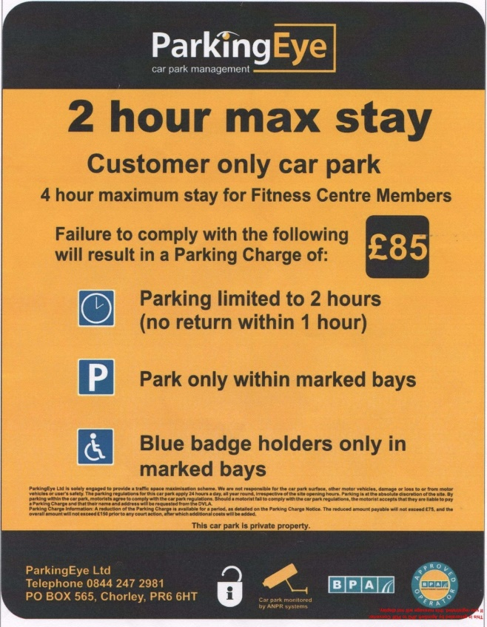
This case, by comparison, does not demonstrate an example of the 'large lettering' and 'prominent signage' that impressed the Supreme Court Judges and swayed them into deciding that in the specific car park in the Beavis case alone, a contract and 'agreement on the charge' existed.
Here, the signs are sporadically placed, indeed obscured and hidden in some areas. They are unremarkable, not immediately obvious as parking terms and the wording is mostly illegible, being crowded and cluttered with a lack of white space as a background. It is indisputable that placing letters too close together in order to fit more information into a smaller space can drastically reduce the legibility of a sign, especially one which must be read BEFORE the action of parking and leaving the car.
Entrance route to estate:

It is vital to observe, since 'adequate notice of the parking charge' is mandatory under the POFA Schedule 4 and the BPA Code of Practice, these signs do not clearly mention the parking charge which is hidden in small print (and does not feature at all on some of the signs). Areas of this site are unsigned and there are no full terms displayed - i.e. with the sum of the parking charge itself in large lettering - at the entrance either, so it cannot be assumed that a driver drove past and could read a legible sign, nor parked near one.
Typical sign (illegible)

This case is more similar to the signage in POPLA decision 5960956830 on 2.6.16, where the Assessor Rochelle Merritt found as fact that signs in a similar size font in a busy car park where other unrelated signs were far larger, was inadequate:
''the signage is not of a good enough size to afford motorists the chance to read and understand the terms and conditions before deciding to remain in the car park. [...] In addition the operators signs would not be clearly visible from a parking space [...] The appellant has raised other grounds for appeal but I have not dealt with these as I have allowed the appeal.''
From the evidence I have seen so far, the terms appear to be displayed inadequately, in letters no more than about half an inch high, approximately. I put the operator to strict proof as to the size of the wording on their signs and the size of lettering for the most onerous term, the parking charge itself.
The letters seem to be no larger than .40 font size going by this guide:
http://www-archive.mozilla.org/newlayout/testcases/css/sec526pt2.htm
As further evidence that this is inadequate notice, Letter Height Visibility is discussed here:
http://www.signazon.com/help-center/sign-letter-height-visibility-chart.aspx
''When designing your sign, consider how you will be using it, as well as how far away the readers you want to impact will be. For example, if you are placing a sales advertisement inside your retail store, your text only needs to be visible to the people in the store. 1-2” letters (or smaller) would work just fine. However, if you are hanging banners and want drivers on a nearby highway to be able to see them, design your letters at 3” or even larger.''
...and the same chart is reproduced here:
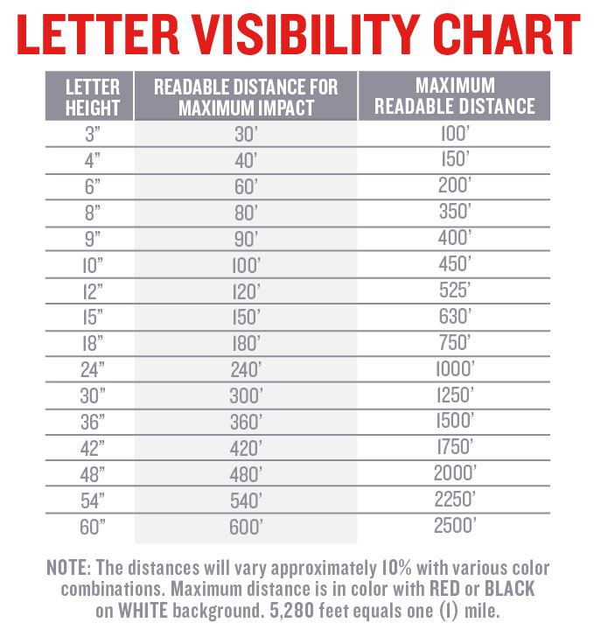
''When designing an outdoor sign for your business keep in mind the readability of the letters. Letters always look smaller when mounted high onto an outdoor wall''.
''...a guideline for selecting sign letters. Multiply the letter height by 10 and that is the best viewing distance in feet. Multiply the best viewing distance by 4 and that is the max viewing distance.''
So, a letter height of just half an inch, showing the terms and the 'charge' and placed high on a wall or pole or buried in far too crowded small print, is woefully inadequate in an outdoor car park. Given that letters look smaller when high up on a wall or pole, as the angle renders the words less readable due to the perspective and height, you would have to stand right in front of it and still need a stepladder (and perhaps a torch and/or magnifying glass) to be able to read the terms.
Under Lord Denning's Red Hand Rule, the charge (being 'out of all proportion' with expectations of drivers in this car park and which is the most onerous of terms) should have been effectively: 'in red letters with a red hand pointing to it' - i.e. VERY clear and prominent with the terms in large lettering, as was found to be the case in the car park in 'Beavis'. A reasonable interpretation of the 'red hand rule' and the 'signage visibility distance' tables above and the BPA Code of Practice, taking all information into account, would require a parking charge and the terms to be displayed far more transparently, on a lower sign and in far larger lettering, with fewer words and more 'white space' as background contrast. Indeed in the Consumer Rights Act 2015 there is a 'Requirement for transparency':
(1) A trader must ensure that a written term of a consumer contract, or a consumer notice in writing, is transparent.
(2) A consumer notice is transparent for the purposes of subsection (1) if it is expressed in plain and intelligible language and it is legible.
The Beavis case signs not being similar to the signs in this appeal at all, I submit that the persuasive case law is in fact 'Vine v London Borough of Waltham Forest [2000] EWCA Civ 106' about a driver not seeing the terms and consequently, she was NOT deemed bound by them.
This judgment is binding case law from the Court of Appeal and supports my argument, not the operator's case:
http://www.bailii.org/ew/cases/EWCA/Civ/2000/106.html

This was a victory for the motorist and found that, where terms on a sign are not seen and the area is not clearly marked/signed with prominent terms, the driver has not consented to - and cannot have 'breached' - an unknown contract because there is no contract capable of being established. The driver in that case (who had not seen any signs/lines) had NOT entered into a contract. The recorder made a clear finding of fact that the plaintiff, Miss Vine, did not see a sign because the area was not clearly marked as 'private land' and the signs were obscured/not adjacent to the car and could not have been seen and read from a driver's seat before parking.
So, for this appeal, I put this operator to strict proof of where the car was parked and (from photos taken in the same lighting conditions) how their signs appeared on that date, at that time, from the angle of the driver's perspective. Equally, I require this operator to show how the entrance signs appear from a driver's seat, not stock examples of 'the sign' in isolation/close-up. I submit that full terms simply cannot be read from a car before parking and mere 'stock examples' of close-ups of the (alleged) signage terms will not be sufficient to disprove this.

1.Unsigned parking bay where vehicle was parked

2. Unsigned parking bay where vehicle was parked

3. Street view (lack of signage)

4. Street view with “marked” parking bays (on left side of the picture) and (no) signage
5. “Marked” parking bays with illegible marking.

No Evidence of Landowner Authority - the operator is put to strict proof of full compliance with the BPA Code of Practice
As this operator does not have proprietary interest in the land, I require that they produce an unredacted copy of the contract with the landowner. The contract and any 'site agreement' or 'User Manual' setting out details including exemptions - such as any 'genuine customer' or 'genuine resident' exemptions or any site occupier's 'right of veto' charge cancellation rights – is key evidence to define what this operator is authorised to do and any circumstances where the landowner/firms on site in fact have a right to cancellation of a charge. It cannot be assumed, just because an agent is contracted to merely put some signs up and issue Parking Charge Notices, that the agent is also authorised to make contracts with all or any category of visiting drivers and/or to enforce the charge in court in their own name (legal action regarding land use disputes generally being a matter for a landowner only).
Witness statements are not sound evidence of the above, often being pre-signed, generic documents not even identifying the case in hand or even the site rules. A witness statement might in some cases be accepted by POPLA but in this case I suggest it is unlikely to sufficiently evidence the definition of the services provided by each party to the agreement.
Nor would it define vital information such as charging days/times, any exemption clauses, grace periods (which I believe may be longer than the bare minimum times set out in the BPA Code of Practice) and basic information such as the land boundary and bays where enforcement applies/does not apply. Not forgetting evidence of the various restrictions which the landowner has authorised can give rise to a charge and of course, how much the landowner authorises this agent to charge (which cannot be assumed to be the sum in small print on a sign because template private parking terms and sums have been known not to match the actual landowner agreement).
Section 7 of the BPA Code of Practice defines the mandatory requirements and I put this operator to strict proof of full compliance:
7.2 If the operator wishes to take legal action on any outstanding parking charges, they must ensure that they have the written authority of the landowner (or their appointed agent) prior to legal action being taken.
7.3 The written authorisation must also set out:
a) the definition of the land on which you may operate, so that the boundaries of the land can be clearly defined
b) any conditions or restrictions on parking control and enforcement operations, including any restrictions on hours of operation
c) any conditions or restrictions on the types of vehicles that may, or may not, be subject to parking control and enforcement
d) who has the responsibility for putting up and maintaining signs
e) the definition of the services provided by each party to the agreement.

