Index

Ignore this page for now, this will get more detailed, go straight to page 2

In the County Court at SOUTHEND

Claim Number: xxxxxxxxxx

UKCPM (Claimant)
V
xxxxxxxxxxxxxx (Defendant)

WITNESS STATEMENT OF DEFENDANT
FOR COURT HEARING ON 23/03/2021

- ‘My Name here and Titles’, and I am the defendant against whom this claim is made. The facts below are true to the best of my belief and my account has been prepared based upon my own knowledge.

- In my statement I shall refer to exhibits within the evidence supplied with this statement, referring to page and reference numbers where appropriate. My defence is repeated, and I will say as follows:

- On 22nd March 2019 I was asked by XXXXXX XXXXXX (Mace Construction Ltd) who was instructed by Knight Dragon (Landowners) to attend site on 23rd March 2019 to deal with an urgent Electrical changeover that needed to take place to keep the construction up and running for over 400 employees the following Monday.

- Please look at Exhibit A which clearly shows the extent of the site, covering the construction and site offices.

- I have drawn a red box showing the extent of the site. Also take note of positions A, B and C. Which relate to the following

- A: place where car was parked.
- B: Manned Security gate controlled by Mace Construction.
- C: Construction Offices.

- Now please look at Exhibit B, Point A shows the manned security gate. Point B shows the permanently locked gate. Point C shows where car was parked. Point D shows the crossing for construction workers. To the left of Point A shows Edmund Halley Way, where the parking eye should have been mapped to monitor.

- I would like to point out that the incident occurred inside a cordoned off building site, and that the parking eye had not been programmed properly to ignore this section of road, which the general public would have no access to. Normal foot patrol has the ability not to issue a parking charge notice, as they would realise this.

- At the point of entry, through the manned security gate there are no signs visible

- However, I received a PCN and now am asked to pay an inflated charge of £160.

- Claimant Witness Statement ‘page 13’. Please look at Exhibit C, which shows a date of 01/03/2019, but said incident happened on 23/3/2019.

- Claimant Witness Statement ‘page 11’. Please look at Exhibit D, Refers to a pay and display machine. Which quite clearly has nothing to do with this case.

- Claimant Witness Statement ‘page 15’. Please look at Exhibit E, I now refer to the Claimants witness statement. Page 15 Shows Schedule 4, where parking enforcement officers to complete a patrol of the agreed the areas. But the Claimant is relying on a mis programmed Parking eye. If this foot patrol had been to the site, they would of acknowledged that a Parking Charge Notice would not apply. I suggest to the court that the claimant has not looked at this case in any detail at all.

- A key factor in the leading authority from the Supreme Court, was that ParkingEye were found to have operated in line with the relevant parking operator’s code of practice and that there were signs that were clear and obvious and 'bound to be seen'. I have included a copy of this

- This situation can be fully distinguished from ParkingEye Ltd v Beavis [2015] UKSC67, where the Supreme Court found that whilst the £85 was not (and was not pleaded as) a sum in the nature of damages or loss, ParkingEye had a 'legitimate interest' in enforcing the charge where motorists overstay, in order to deter motorists from occupying spaces beyond the time paid for and thus ensure further income for the landowner, by allowing other motorists to occupy the space. The Court concluded that the £85.00 charge was not out of proportion to the legitimate interest (in that case, based upon the facts and clear signs) and therefore the clause was not a penalty clause.

The Beavis case is against this claim

- However, there is no such legitimate interest where the requisite fee has been paid in full for the time stayed. As such, I take the point that the parking charge in my case is a penalty, and unenforceable. This is just the sort of 'concealed pitfall or trap' and unsupported penalty that the Supreme Court had in mind when deciding what constitutes a (rare and unique case) 'justified' parking charge as opposed to an unconscionable one.
- The Claimant has added a sum disingenuously described as 'damages/admin' or 'debt collection costs'. The added £60 constitutes double recovery and the court is invited to find the quantum claimed is false and an abuse of process - see exhibit xx-12 - transcript of the Approved judgment in Britannia Parking v Crosby (Southampton Court 11.11.19). That case was not appealed and the decision stands.

- Whilst it is known that another case that was struck out on the same basis was appealed to Salisbury Court (the Semark-Jullien case), the parking industry did not get any finding one way or the other about the illegality of adding the same costs twice. The Appeal Judge merely pointed out that he felt that insufficient information was known about the Semark-Jullien facts of the case (the Defendant had not engaged with the process and no evidence was in play, unlike in the Crosby case) and so the Judge listed it for a hearing and felt that case (alone) should not have been summarily struck out due to a lack of any facts and evidence.

- The Judge at Salisbury correctly identified as an aside, that costs were not added in the Beavis case. That is because this had already been addressed in ParkingEye's earlier claim, the pre- Beavis High Court (endorsed by the Court of Appeal) case ParkingEye v Somerfield (ref para 419): https://www.bailii.org/ew/cases/EWHC/QB/2011/4023.html
- ''It seems to me that, in the present case, it would be difficult for ParkingEye to justify, as against any motorist, a claim for payment of the enhanced sum of £135 if the motorist took the point that the additional £60 over and above the original figure of £75 constituted a penalty. It might be possible for ParkingEye to show that the additional administrative costs involved were substantial, though I very much doubt whether they would be able to justify this very large increase on that basis. On the face of it, it seems to me that the predominant contractual function of this additional payment must have been to deter the motorist from breaking his contractual obligation to pay the basic charge of £75 within the time specified, rather than to compensate ParkingEye for late payment. Applying the formula adopted by Colman J. in the Lordsvale case, therefore, the additional £60 would appear to be penal in nature; and it is well established that, in those circumstances, it cannot be recovered, though the other party would have at least a theoretical right to damages for breach of the primary obligation.''

- Abuse of process - the quantum

- This stopped ParkingEye from using that business model again, particularly because HHJ Hegarty had found them to have committed the 'tort of deceit' by their debt demands. So, the Beavis case only considered an £85 parking charge but was clear at paras 98, 193 and 198 that the rationale of that inflated sum (well over any possible loss/damages) was precisely because it included (the Judges held, three times) 'all the costs of the operation'. It is an abuse of process to add sums that were not incurred. Costs must already be included in the parking charge rationale if a parking operator wishes to base their model on the ParkingEye v Beavis case and not a damages/loss model. This Claimant can't have both.

- This Claimant knew or should have known, that by adding £60 in costs over and above the purpose of the 'parking charge' to the global sum claimed is unrecoverable, due to the POFA at 4(5), the Beavis case paras 98, 193 and 198 (exhibit - xx-10), the earlier ParkingEye Ltd v Somerfield High Court case and the Consumer Rights Act 2015 ('CRA') Sch 2, paras 6, 10 and
- 14. All of those seem to be breached in my case and the claim is pleaded on an incorrect premise with a complete lack of any legitimate interest.
- Not drawing onerous terms to the attention of a consumer breaches Lord Denning's 'red hand rule' and in addition the global sum on the particulars of claim is unfair under the
- CRA. Consumer notices are never exempt from the test of fairness and the court has a duty under s71 of the CRA to consider the terms and the signs to identify the breaches of the CRA. Not only is the added vague sum not stated on the notices at all (despite the Claimant
- claiming it is in their Witness Statement in writing and by appending signage that does not exist at the car park), but the official CMA guidance to the CRA covers this and makes it clear that words like 'indemnity' are objectionable in themselves and any term trying to allow a trader to recover costs twice would (of course) be void, even if the added sum was on the signs.

- CPR 44.11 - further costs

- I am appending with this bundle, a fully detailed costs assessment which also covers my proportionate but unavoidable further costs and I invite the court to consider making an award to include these, pursuant to the court's powers in relation to misconduct (CPR 44.11). In support of that argument. This is compounded by the witness altering the Statement of Truth (an attempt to avoid a personal duty) and attaching stock images of signs instead of actual images and a redacted 'landowner authority' document that could be from anyone.

- My fixed witness costs - ref PD 27, 7.3(1) and CPR 27.14

- As a litigant-in-person I have had to learn relevant law from the ground up and spent a considerable time researching the law online, processing and preparing my defence plus
- this witness statement. I ask for my fixed witness costs. I am advised that costs on the Small Claims track are governed by rule 27.14 of the CPR and (unless a finding of 'wholly unreasonable conduct' is made against the Claimant) the Court may not order a party to pay another party’s costs, except fixed costs such as witness expenses which a party has reasonably incurred in travelling to and from the hearing (including fares and/or parking fees) plus the court may award a set amount allowable for loss of earnings or loss of leave.

- The fixed sum for loss of earnings/loss of leave apply to any hearing format and are fixed costs at PD 27, 7.3(1) ''The amounts which a party may be ordered to pay under rule 27.14(3)(c) (loss of earnings)... are: (1) for the loss of earnings or loss of leave of each party or witness due to attending a hearing ... a sum not exceeding £120 per day for each person.''

Statement of truth:

- I believe that the facts stated in this Witness Statement are true. I understand that proceedings for contempt of court may be brought against anyone who makes, or causes to be made, a false statement in a document verified by a statement of truth without an honest belief in its truth.

SIGNATURE

XXXXXXXXXX XXXXXX

Exhibit A

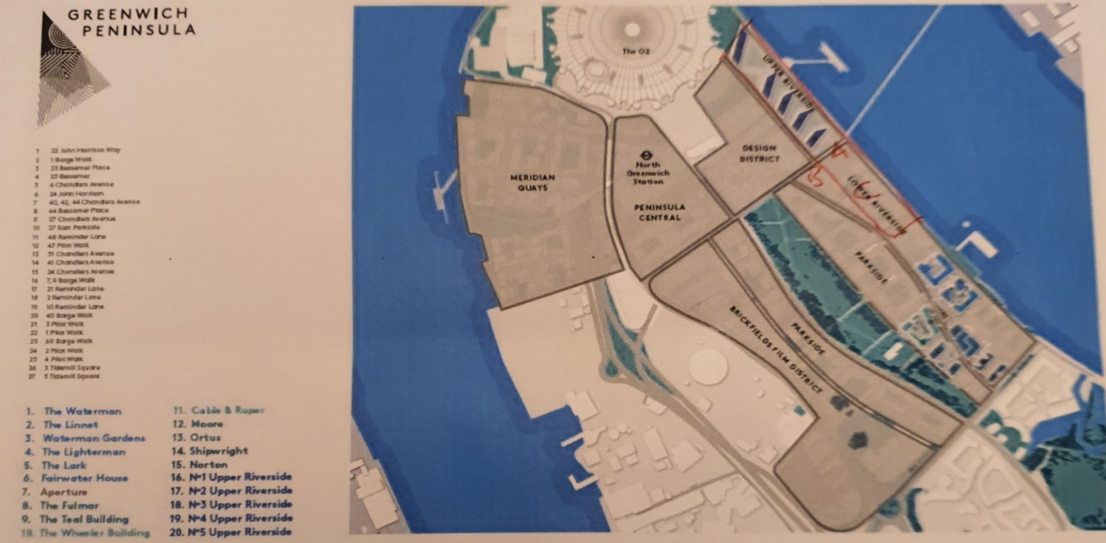

Exhibit B

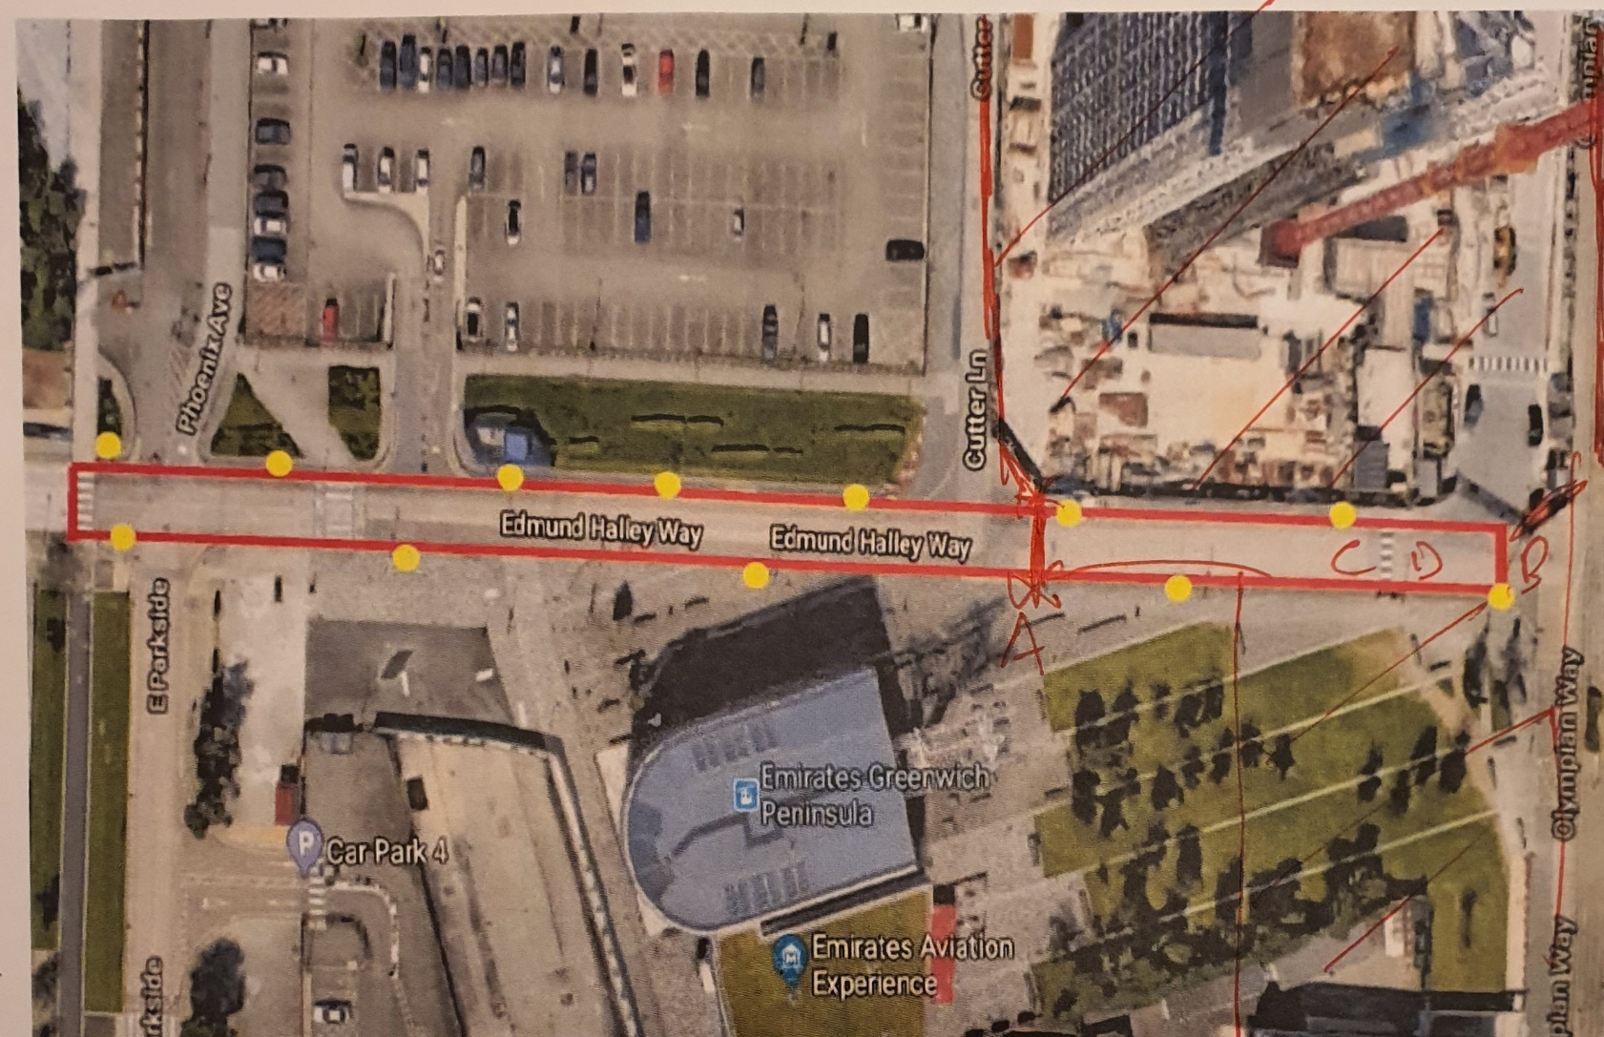

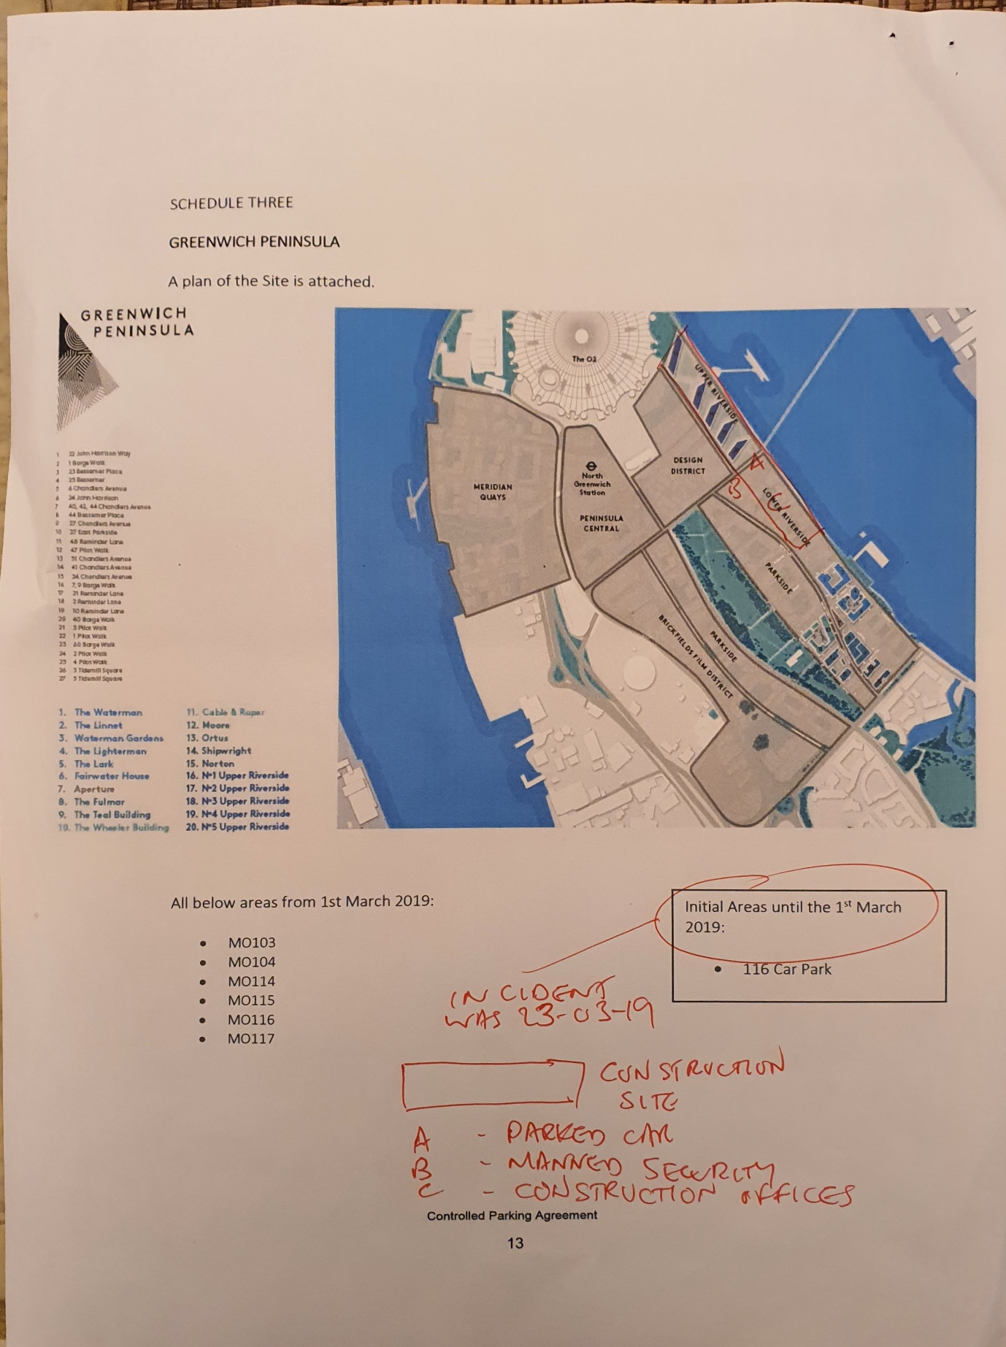
Exhibit C

Exhibit D
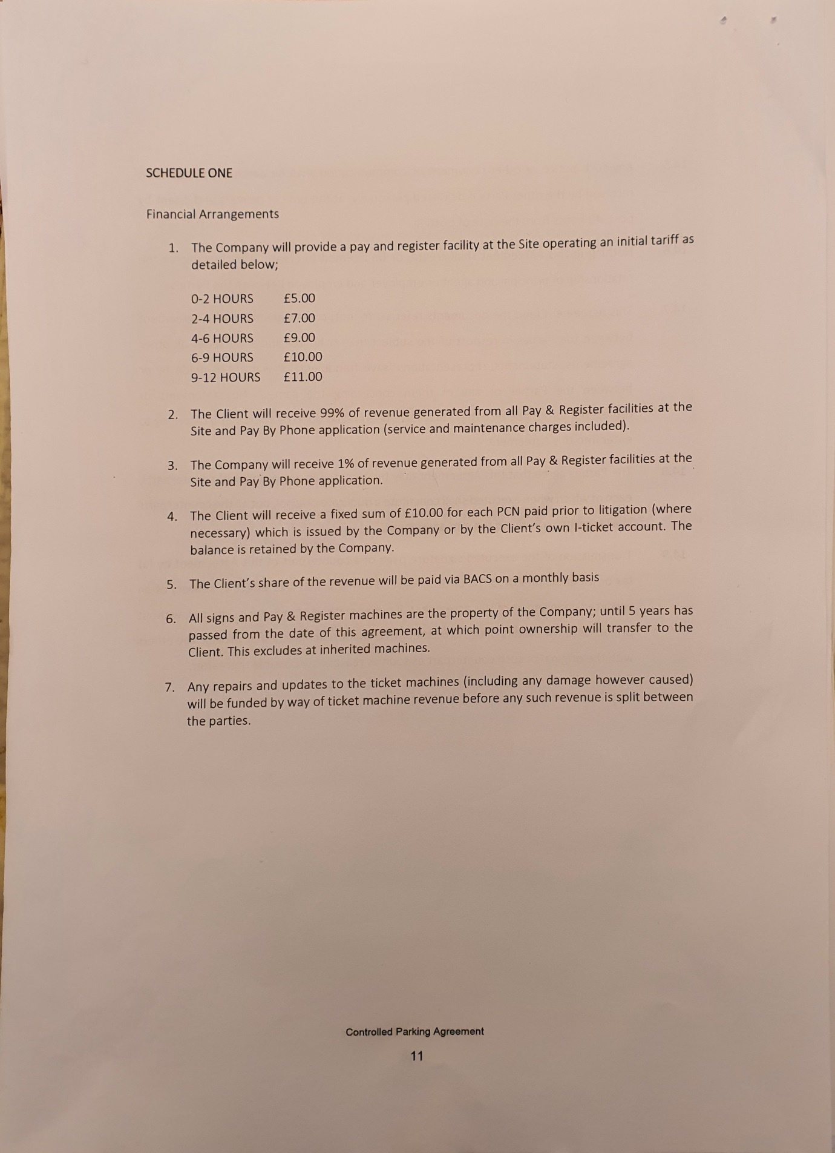

Exhibit E
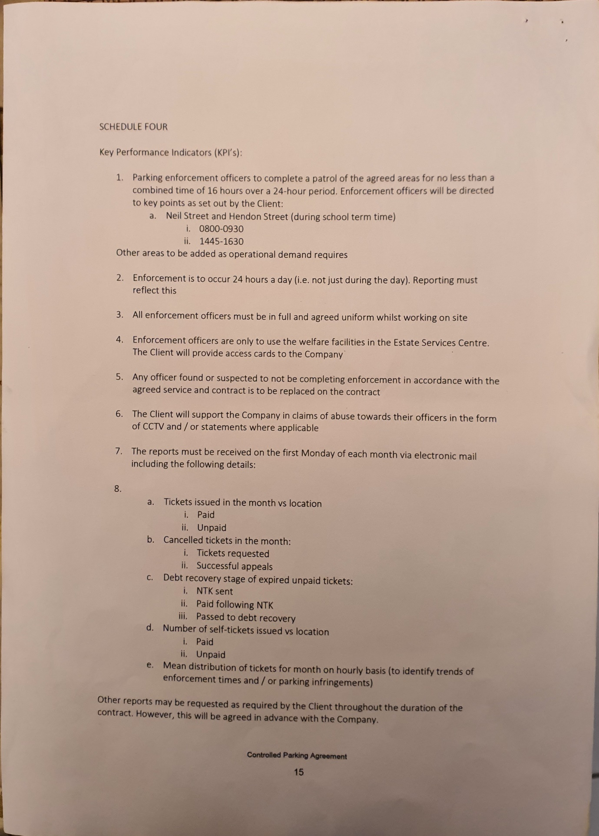

More Exhibits here

Ignore this, as cut from document. Here in case of repaste.
- No evidence of Landowner Authority - the operator is put to strict proof of full compliance with the BPA Code of Practice
As this operator does not have proprietary interest in the land then I require that they produce an unredacted copy of the contract with the landowner.
The contract and any 'site agreement' or 'User Manual' setting out details - such as any 'genuine customer' or 'genuine resident' exemptions or any site occupier's 'right of veto' charge cancellation rights, and of course all enforcement dates/times/days, and the boundary of the site - is key evidence to define what this operator is authorised to do, and when/where.
It cannot be assumed, just because an agent is contracted to merely put some signs up and issue Parking Charge Notices, that the agent is authorised on the material date, to make contracts with all or any category of visiting drivers and/or to enforce the charge in court in their own name (legal action regarding land use disputes generally being a matter for a landowner only).
Witness statements are not sound evidence of the above, often being pre-signed, generic documents not even identifying the case in hand or even the site rules. A witness statement might in some cases be accepted by POPLA but in this case I suggest it is unlikely to sufficiently evidence the definition of the services provided by each party to the agreement.
Nor would it define vital information such as charging days/times, any exemption clauses, grace periods (which I believe may be longer than the bare minimum times set out in the BPA CoP) and basic but crucial information such as the site boundary and any bays where enforcement applies/does not apply. Not forgetting evidence of the only restrictions which the landowner has authorised can give rise to a charge, as well as the date that the parking contract began, and when it runs to, or whether it runs in perpetuity, and of course, who the signatories are: name/job title/employer company, and whether they are authorised by the landowner to sign a binding legal agreement.
Paragraph 7 of the BPA CoP defines the mandatory requirements and I put this operator to strict proof of full compliance:
7.2 If the operator wishes to take legal action on any outstanding parking charges, they must ensure that they have the written authority of the landowner (or their appointed agent) prior to legal action being taken.
7.3 The written authorisation must also set out:
a the definition of the land on which you may operate, so that the boundaries of the land can be clearly defined
b any conditions or restrictions on parking control and enforcement operations, including any restrictions on hours of operation
c any conditions or restrictions on the types of vehicles that may, or may not, be subject to parking control and enforcement
d who has the responsibility for putting up and maintaining signs
e the definition of the services provided by each party to the agreement

