In the County Court at x
Claim No. x
Between
x
And
x

Index to bundle for hearing on x

Section A
Witness Statement 1-8
Statement of Truth 9

Section B
x-01 – Entrance sign photo evidence 10
x-02 – Claimaint’s site map & sign locations 11
x-03 – Landowner vs Claimant entrance signs 12
x-04 – On-site sign located behind Defendant’s car 13
x-05 – Parking enforcement contractual agreement 14-17
x-06 – On-site Parking Conditions wording 18
x-07 – Pace vs Lengyel 19-25
x-08 – Example from the International Parking Community Code of Practice V6 26
x-09 – Britannia v Crosby 27-34
x-10 – VCS v Davies 35

Section C
x-11 – Defendants Schedule of Costs 36

In the County Court at x
Claim No. x
Between
x
And
x

Witness Statement for Telephone Hearing on x

- I am x of x, the Defendant against whom this claim is made. I will say as follows:

- My defence is repeated and I was the Driver of the vehicle at the time of the contravention alleged by the Claimant. However, I argue in this Witness Statement that there was no contract entered into between the Defendant and Claimant.

No contract seen or agreed

- There was insufficient signage at the entrance to the site indicating the Claimant had enforced parking restrictions, due to it being partially removed and partially hidden by foliage – see photo taken by the Defendant on the day of the alleged contravention X-01. Referring to the Claimant’s Site Map in her Witness Statement – see X-02 – this shows that this was the only sign at the entrance/exit to this site, which the Claimant failed to maintain to a reasonable standard for a driver to observe as they entered the site.

- The Claimant is a member of the International Parking Community. Part E Schedule 1 – Signage of their Code of Practice V6 [Jun-17] (in force at the time of the alleged parking contravention) provides:
  - “Signs should be constructed from material that is sufficiently robust to withstand normal external conditions. Signs must be professionally made and not hand-written so it is immediately apparent to the motorist that they convey important information regarding the site upon which they are placed.”.
  - “Signs should , where practicable, be placed at the entrance to a site.”
  - “Where there is any change to any pre-existing terms and conditions that would not be immediately apparent to a person visiting the site and which materially affects the motorist you should place additional (temporary) signage at the entrance making it clear that new terms and conditions/charges apply, such that regular visitors who may be familiar with the old terms do not inadvertently incur parking charges. This signage should be in addition to the signage ordinarily required and left in place for an appropriate period”.

- It is asserted by the Defendant that the materials used for the sign were insufficient to meet either the guidance or spirit of the guidance in 4.1 given its state. Similarly, 4.2 could not be met given that the remainder of the sign could not allude to the Claimant’s parking restrictions in operation. It is also believed that the Claimant failed to meet guidance in 4.3, as the Defendant had used this car park previously having lived in the apartment block directly opposite, so was aware that many non-permit holders used this car park out of peak working time hours in order to visit the local area. As the more prominent sign for the land owner remained in place (see photo taken by the Defendant on the day of the alleged contravention X-03) with no signage/notices by the Claimant, the Defendant had the honest belief that there was no change in parking restrictions.

- Only on finding the parking charge ticket did the Defendant discover the remainder of the entrance sign, along with an additional sign affixed to a low fence behind his parked vehicle, (see photo taken by the Defendant on the day of the alleged contravention X-04) that could have easily been occluded whilst parking given its size and location. Part E Schedule 1 – Signage ‘Other Signs’ states these signs must, “Be clearly legible and placed in such a position (or positions) such that a driver of a vehicle is able to see them clearly upon entering the site or parking a vehicle within the site” and “Contain text appropriate to the position of the sign and the relative position of the person who it is aimed at”. It is of the opinion of the Defendant that neither of these conditions of the Claimant’s Code of Practice were met.

- The Defendant had been afforded no fair opportunity to learn that parking restrictions had changed and was therefore under no duty to seek them out (as held in Vine v London Borough of Waltham Forest [2000] EWCA Civ 1069). I note from research about similar cases that Claimants are known to mislead courts using this authority by quoting out of context from Roch LJ, whose words related to the Respondent’s losing case, and not from the decision. In fact, Miss Vine won because it was held as a fact that she was not afforded a fair opportunity to learn of the terms by which she would be bound.

Defective Contract

- Paragraphs 4 and 6 of the Claimant’s Witness Statement refer to a contractual agreement with the landowner that, the Claimant asserts, grants them the authority to enforce parking charges (see X-05). The contract states that the land owner (‘proprietor’) is Unitarian New Meeting, an unincorporated charity.

- As the charity is not an incorporated entity, the contract fails the requirements of Section 44 of the Companies Act 2006, and therefore is not a valid contract. The particular section states, “(1) Under the law of England and Wales or Northern Ireland a document is executed by a company— (a) by the affixing of its common seal, or (b) by signature in accordance with the following provisions. (2) A document is validly executed by a company if it is signed on behalf of the company— (a) by two authorised signatories, or (b) by a director of the company in the presence of a witness who attests the signature. (3) The following are “authorised signatories” for the purposes of subsection (2)— (a) every director of the company, and (b) in the case of a private company with a secretary or a public company, the secretary (or any joint secretary) of the company”.

- Referring to the alleged contract – see X-05 – it has not been executed in accordance with subsection 1 because it has not been signed by two people from each company (the Claimant and the Proprietor) nor by a director and witness of each company in accordance with the requirements of subsection 2. In addition, it has not been signed by authorised signatories as defined in subsection 3. Further, the signatures have been redacted so it is required that the Claimant has to prove they relate to actual employees of both of the companies concerned as there is no indication on the document that they actually work for the two named companies or in what capacity.

- Additionally, the signage in the site from the Claimants Witness Statement (see X-06) refers to permit holders only, as required by the agreement. This arguably excludes all non-permit holders, so a contract could not be granted to anyone without already being in possession of one.

- Given the above arguments, the Defendant is of the opinion that the contract was not valid with the above Act of Parliament, therefore any parking charge notices are also invalid as the Claimant had no authority to grant them on the site because they did not have a valid contract with the landowner or authority to manage the site.

- Furthermore, in case number F1DP92KF heard at Truro County Court on the 03/07/20, District Judge Simon Middleton stated that, "Claire Williams could not have signed the contract on behalf of the owner because she is not a director of the owner". In this case, there is no proof from the Claimant that the unidentified proprietor signatory was a director of the landowner and was authorised to sign the contract on behalf of the landowner.

- Referring to the case of Hancock vs Promontoria (Chestnut) Ltd, the Appeal Court found that a, “document must in all normal circumstances be placed before the court as a whole…” and “Seldom, if ever, can it be appropriate for one party unilaterally to redact provisions in a contractual document which the court is being asked to construe, merely on grounds of confidentiality” and “Confidentiality alone cannot be a good reason for redacting an otherwise relevant provision”. It is therefore incumbent on the Claimant to present the whole contract unredacted before the court.

The contract requiring a permit was void for impossibility

- Referring to the judgment Pace vs Lengyel C7GF6E3R – appended in this pack as X-07, District Judge Iyer had to be satisfied with the following in order for the Defendant to be in breach of the terms of the contract to display a permit:
  - The Claimant had the authority of the owner or occupier of the site to enter into contracts with people who parked their cars in the car park.
  - The Claimant and the Defendant entered into such a contract.
  - It was a valid and enforceable contract

- Refer to the previous section for my argument of Defective Contract in relation to criteria 15.1 above.

- In regards to criteria 15.2, the Claimant alleges that the Defendant was in breach of the terms of parking stipulated on the signage thereby forming a ‘contract’, therefore leading to the parking charge of £100. However, referring to section 62 of the Consumer Rights Act 2015, this has to be a “fair” consumer contract. As the Supreme Court held in ParkingEye Ltd v Beavis [2013] EWCA Civ 1539 and [2015] EWCA Civ 402, the concept of fairness requires the parking firm to comply with the requirements of the relevant code of practice, being either the British Parking Association’s code or the International Parking Community’s code.

- As stated earlier in this document, the Claimant is a member of the International Parking Community. Part E Schedule 1 – Signage ‘Entrance Signs’ of the Code of Practice states, “Entrance Signs should b) Refer the motorist to the signs within the car park which display the full terms and conditions.”

- Part E Schedule 1 – Signage ‘Other Signs’ of their Code of Practice provides, “You must adequately display any signs intended to form the basis of contract between the creditor and the driver”.

- Refer to X-08 for an example provided by the International Parking Community Code of Practice V6 for comparison to photo evidence X-01 that was taken of the ‘entrance sign’ on the date of the alleged contravention. Given the ‘entrance sign’ was nearly entirely removed, it was impossible for the Defendant to be referred to other signs within the site to view the full terms and conditions.

- Part E Schedule 1 – Signage ‘Other Signs’ of the Code of Practice also states the following in addition to the entrance signs requirements, “Have clear and intelligible wording and be designed such that it is clear to the reasonable driver that he is entering into a contract with the creditor or committing a trespass as the case may be”.

- Referring to the “Parking Conditions” text in X-06, nowhere within it does it inform the reader that by parking in the car park he is entering into a contract with the Claimant. Indeed, the word “contract” does not appear at all within the sign, which merely refers that, “By entering or remaining on this land you agree to abide by all of the Terms and Conditions”. The phrase “terms and conditions” is not synonymous with a contract.

- In regards to criteria 15.3, if the Claimant is insisting that the Defendant entered into a contract when entering the site, then the lack of sign at the entrance to the car park would mean a breach as soon as the Defendant entered the site without any warning given the partially removed sign, (X-01) – as there would not be any time to source a permit to display. The inability to do this was not caused by any act or omission on the part of the Defendant, but by a state of affairs over which he had no control. Therefore, insofar as there was any contract between the parties, the Defendant believes it was invalid under the doctrine of impossibility of performance.

Inflated and false 'costs' have been added to the parking charge

- The added £60 constitutes double recovery and the court is invited to find the quantum claimed is false and an abuse of process – see X-09 – transcript of the Approved judgment in Britannia Parking v Crosby (Southampton Court 11/11/19). That case was not appealed and the decision in the case of Mr Crosby stands. This Claimant knew or should have known, that by adding £60 in false (unpaid) 'costs/damages' over and above the purpose of the 'parking charge' is unrecoverable, due to the POFA at 4(5), the Beavis case paras 98, 193 and 198, and para 419 of the earlier ParkingEye Ltd v Somerfield Court of Appeal authority. As an experienced parking operator, the Claimant should also know that the 60% uplift does not pass when compared to the CRA s62, expanded with examples of 'terms that are likely to be unfair' in Schedule 2 (paragraphs 6, 10 and 14 appear to be breached in my case).

- This situation can be fully distinguished from ParkingEye Ltd v Beavis [2015] UKSC67, where the Supreme Court found that whilst the £85 was not (and was not pleaded as) a sum in the nature of damages or loss, ParkingEye had a 'legitimate interest' in enforcing the charge where motorists overstay, in order to deter motorists from occupying spaces beyond the time paid for and thus ensure further income for the landowner, by allowing other motorists to occupy the space. The Court concluded that the £85.00 charge was not out of proportion to the legitimate interest (in that case, based upon the facts and clear signs) and therefore the clause was not a penalty clause, when all the facts of that case were examined. However, there is no such legitimate interest in this case.

- I take the point that the enhanced parking charge in my case is a penalty, and unenforceable. This is just the sort of 'concealed pitfall or trap' and unsupported penalty that the Supreme Court had in mind when deciding what constitutes a (rare and unique case) 'justified' parking charge as opposed to an unconscionable one. Please refer again to the Southampton Court Approved Judgment in Britannia Parking v Crosby (X-09), where the question of enhancing a parking charge by a disproportionate percentage (for costs that were neither properly incurred nor additional to the core 'debt') was recently tested.

- Whilst it is known that another decision to strike out a parking claim was appealed to Salisbury Court (the Semark-Jullien case), the parking industry did not get anywhere finding one way or the other about the illegality of adding the same (unpaid and false) costs twice. The Appeal Judge merely pointed out that he felt that insufficient information was known about the facts of that case, where the Defendant had not appealed nor engaged with the process and no evidence was in play, unlike in the Crosby case. The Salisbury Appeal Judge merely listed the Semark-Jullien case for a hearing and felt that case (alone) should not have been summarily struck out due to a lack of any facts and evidence. In short, that was an appeal against the striking out as a 'draconian measure' and not - as this Claimant may have it - some sort of landmark appeal about the illegality of adding false sums to a parking charge.

- The Judge at Salisbury correctly identified that costs were not added in the Beavis case. True - but (unbeknown to the Salisbury Judge because the Appellant failed to draw the relevant case law to his attention) that had already been addressed in ParkingEye's earlier claim, the authority in ParkingEye v Somerfield [2011] EWHC 4023 (QB) High Court case (ratified by the Court of Appeal in 2012), ref pargraph 419 from HHJ Hegarty:
''It seems to me that, in the present case, it would be difficult for ParkingEye to justify, as against any motorist, a claim for payment of the enhanced sum of £135 if the motorist took the point that the additional £60 over and above the original figure of £75 constituted a penalty. It might be possible for ParkingEye to show that the additional administrative costs involved were substantial, though I very much doubt whether they would be able to justify this very large increase on that basis. On the face of it, it seems to me that the predominant contractual function of this additional payment must have been to deter the motorist from breaking his contractual obligation to pay the basic charge of £75 within the time specified, rather than to compensate ParkingEye for late payment. Applying the formula adopted by Colman J. in the Lordsvale case, therefore, the additional £60 would appear to be penal in nature; and it is well established that, in those circumstances, it cannot be recovered, though the other party would have at least a theoretical right to damages for breach of the primary obligation.''

- This stopped ParkingEye from using that business model again, particularly because HHJ Hegarty had found them to have committed the 'tort of deceit' by their aggressive and misleading debt demands, which appear to have been very similar to those I received. Costs must already be included in the parking charge rationale if a parking operator wishes to base their model on the ParkingEye v Beavis case and not a damages/loss model. This Claimant can't have both.

- It is certainly an abuse of process to add sums that were not incurred. However, the Salisbury Appeal Judge was not informed by the Claimant's representative that these enhanced costs were known to be false, following thousands of claims heard by the Courts, where parking firms have been warned not to file claims like it again. X-10 appended to this pack shows the exasperated words of District Judge Jones-Evans sitting at Caernarfon court in April 2020, when striking out a similar inflated claim by VCS, after warning parking company advocates over a 'very significant period of time' not to bring cases to court where the parking charge has been inflated by an unrecoverable sum of money dressed up as the costs that must already be within the parking charge itself. There can be no excuse that this Claimant, or their advocate, 'doesn't know' that adding false sums to inflate a claim is an abuse of process and the Salisbury Appeal case is entirely distinguished.

My fixed witness costs – ref PD 27, 7.3(1) and CPR 27.14

- I ask the Court at the very least for my fixed witness costs. I am advised that costs on the Small Claims track are governed by rule 27.14 of the CPR and (unless a finding of 'wholly unreasonable conduct' is made against the Claimant) the Court may not order a party to pay another party’s costs, except fixed costs such as witness expenses which a party has reasonably incurred in travelling to and from the hearing, plus the court may award a set amount allowable for loss of earnings or loss of leave.

- Travel costs do not apply for a telephone hearing but the fixed sum for loss of earnings/loss of leave apply to any hearing format and are fixed at PD 27, 7.3(1) ''The amounts which a party may be ordered to pay under rule 27.14(3)(c) (loss of earnings)... are: (1) for the loss of earnings or loss of leave of each party or witness due to attending a hearing ... a sum not exceeding £95 per day for each person.''

Further costs for the wholly unreasonable conduct of this Claimant – CPR 44.11

- As a litigant-in-person, I have had to learn relevant law from the ground up and spent a considerable time researching the law online, processing and preparing my defence plus this witness statement and related materials. My personal life has been severely impacted and this matter has been hanging over me for 2 years. I am appending with this bundle, a fully detailed costs assessment that also covers my proportionate further costs and I invite the court to consider making an award to include these, pursuant to the court's powers in relation to misconduct (CPR 44.11). Not only could this claim have been avoided and the Claimant has no cause of action and no legitimate interest in pursuing me, relying upon the entrapment of insufficient signage, but it is also vexatious to pursue an inflated sum that includes double recovery. It is my position that the Claimant's conduct in pre-and post-litigation has crossed the line of unreasonable conduct.

- I Invite the Court to dismiss this claim in its entirety, and to award my costs of attendance at the hearing, as such as are allowable pursuant to CPR 27.14, see X-11.

Statement of Truth

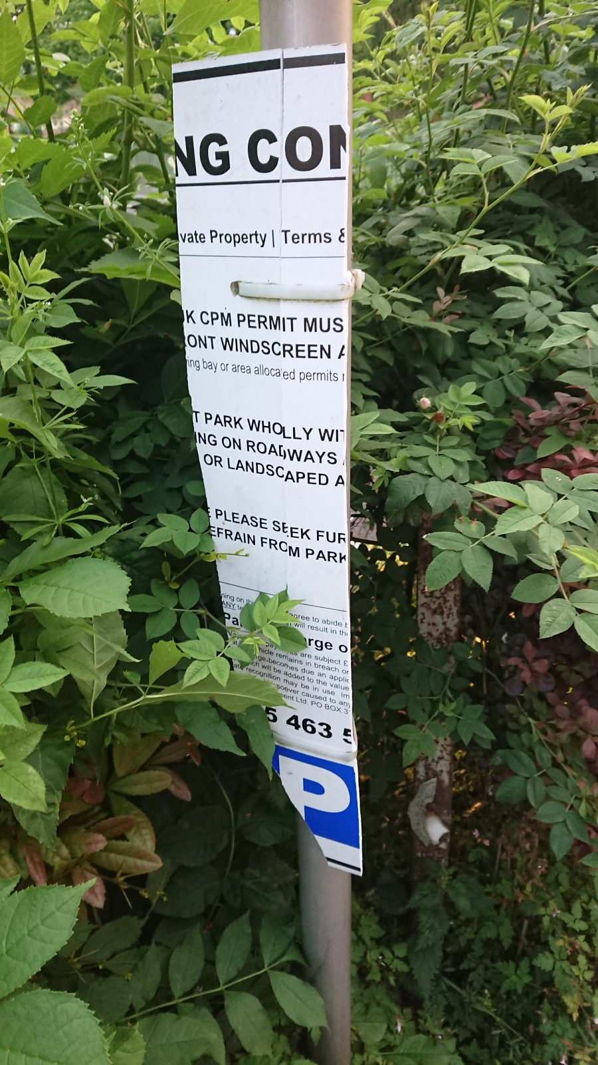
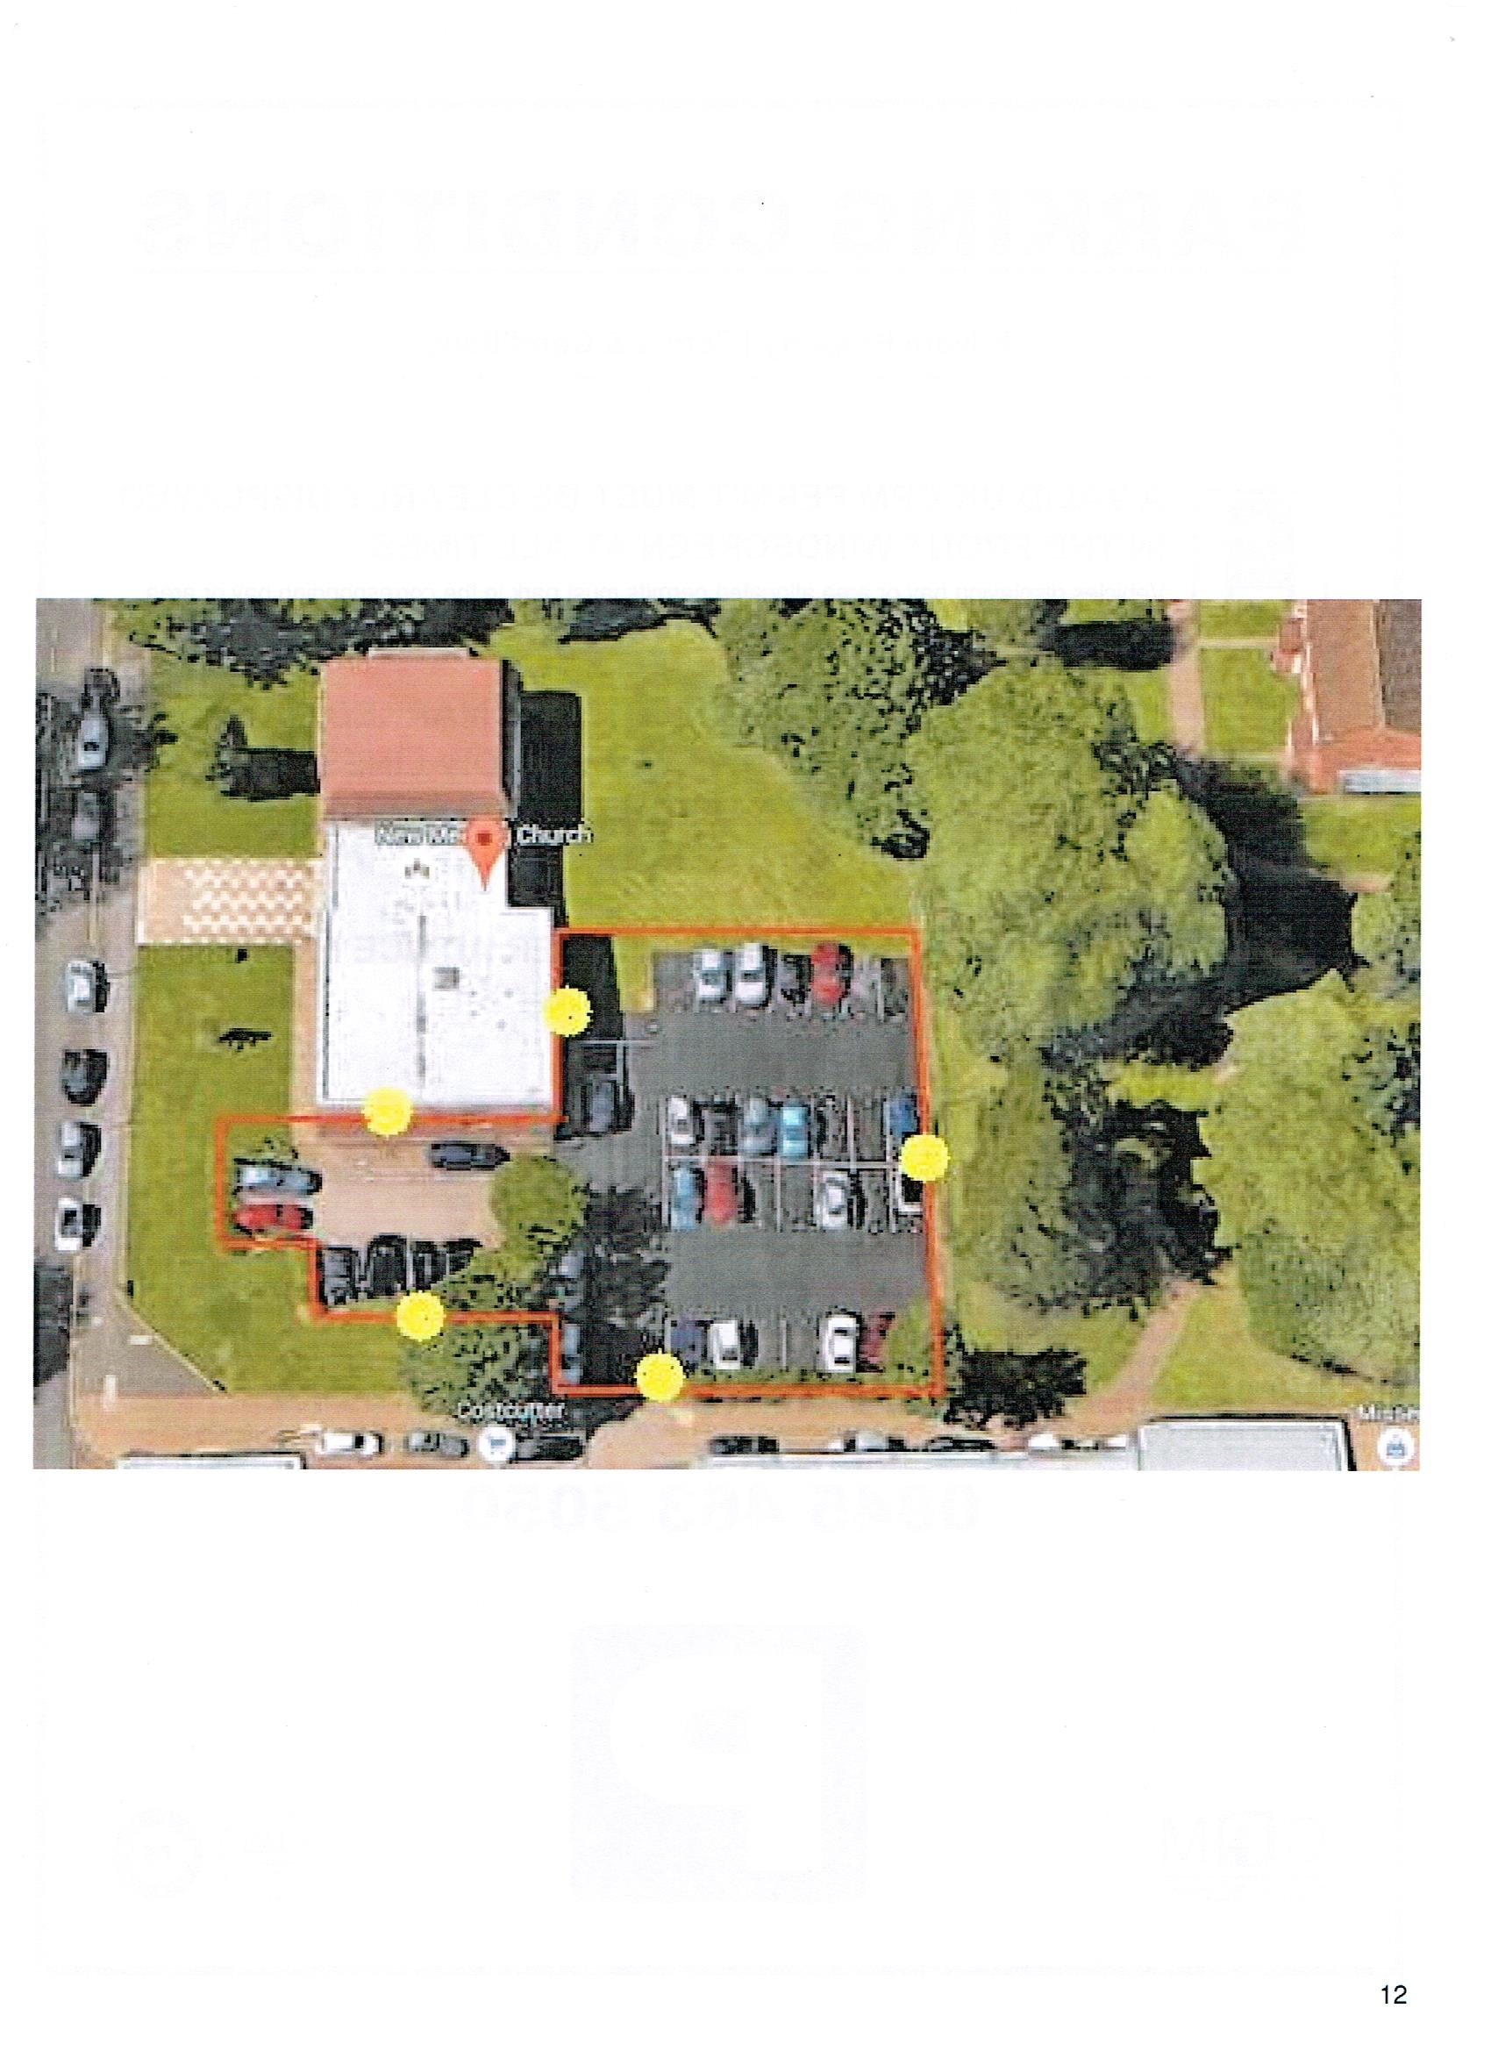

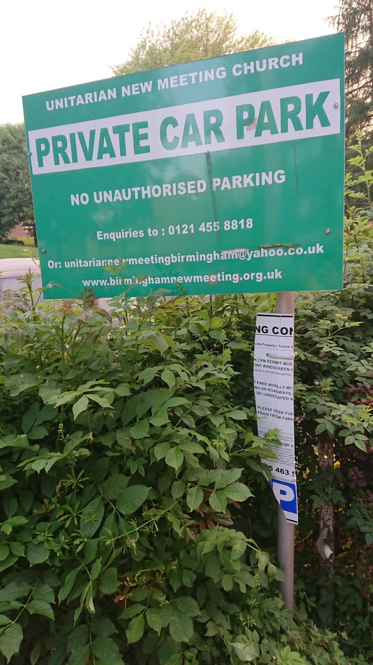
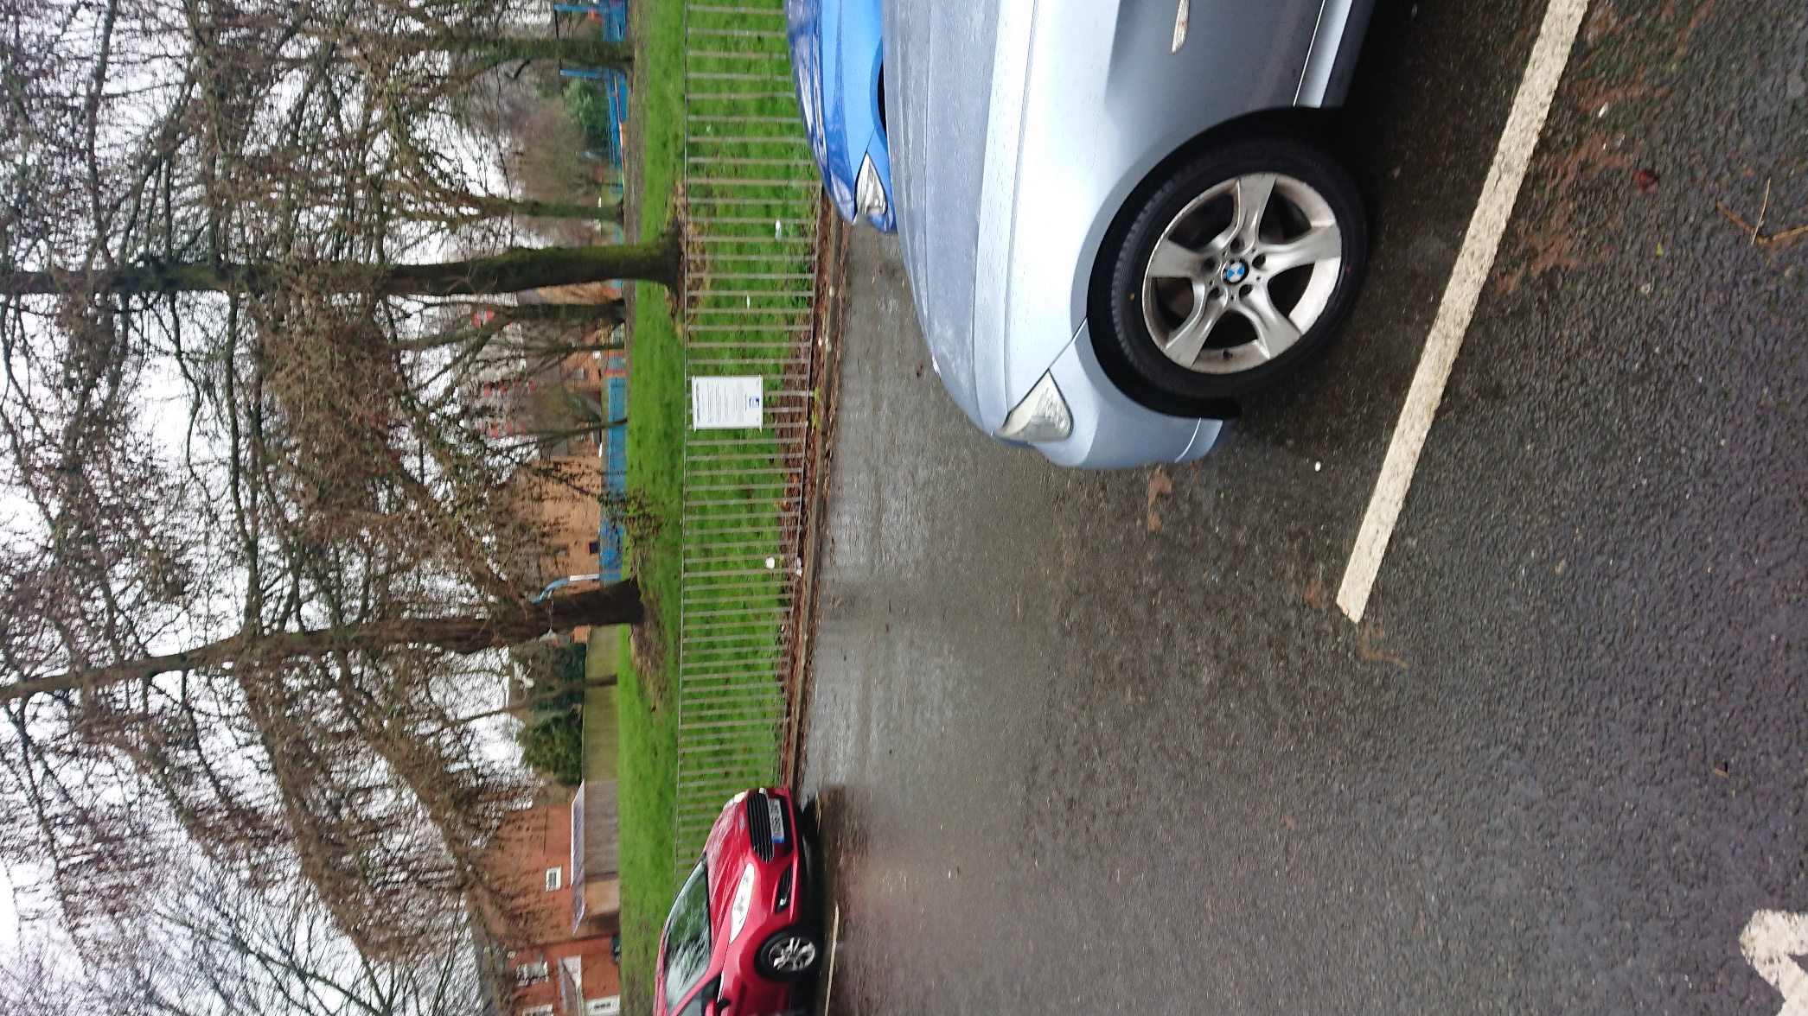
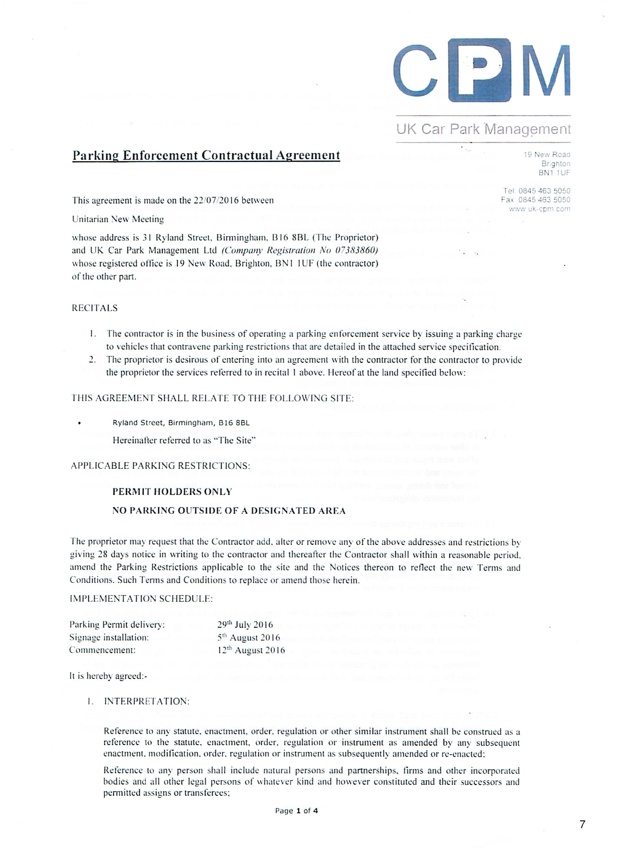

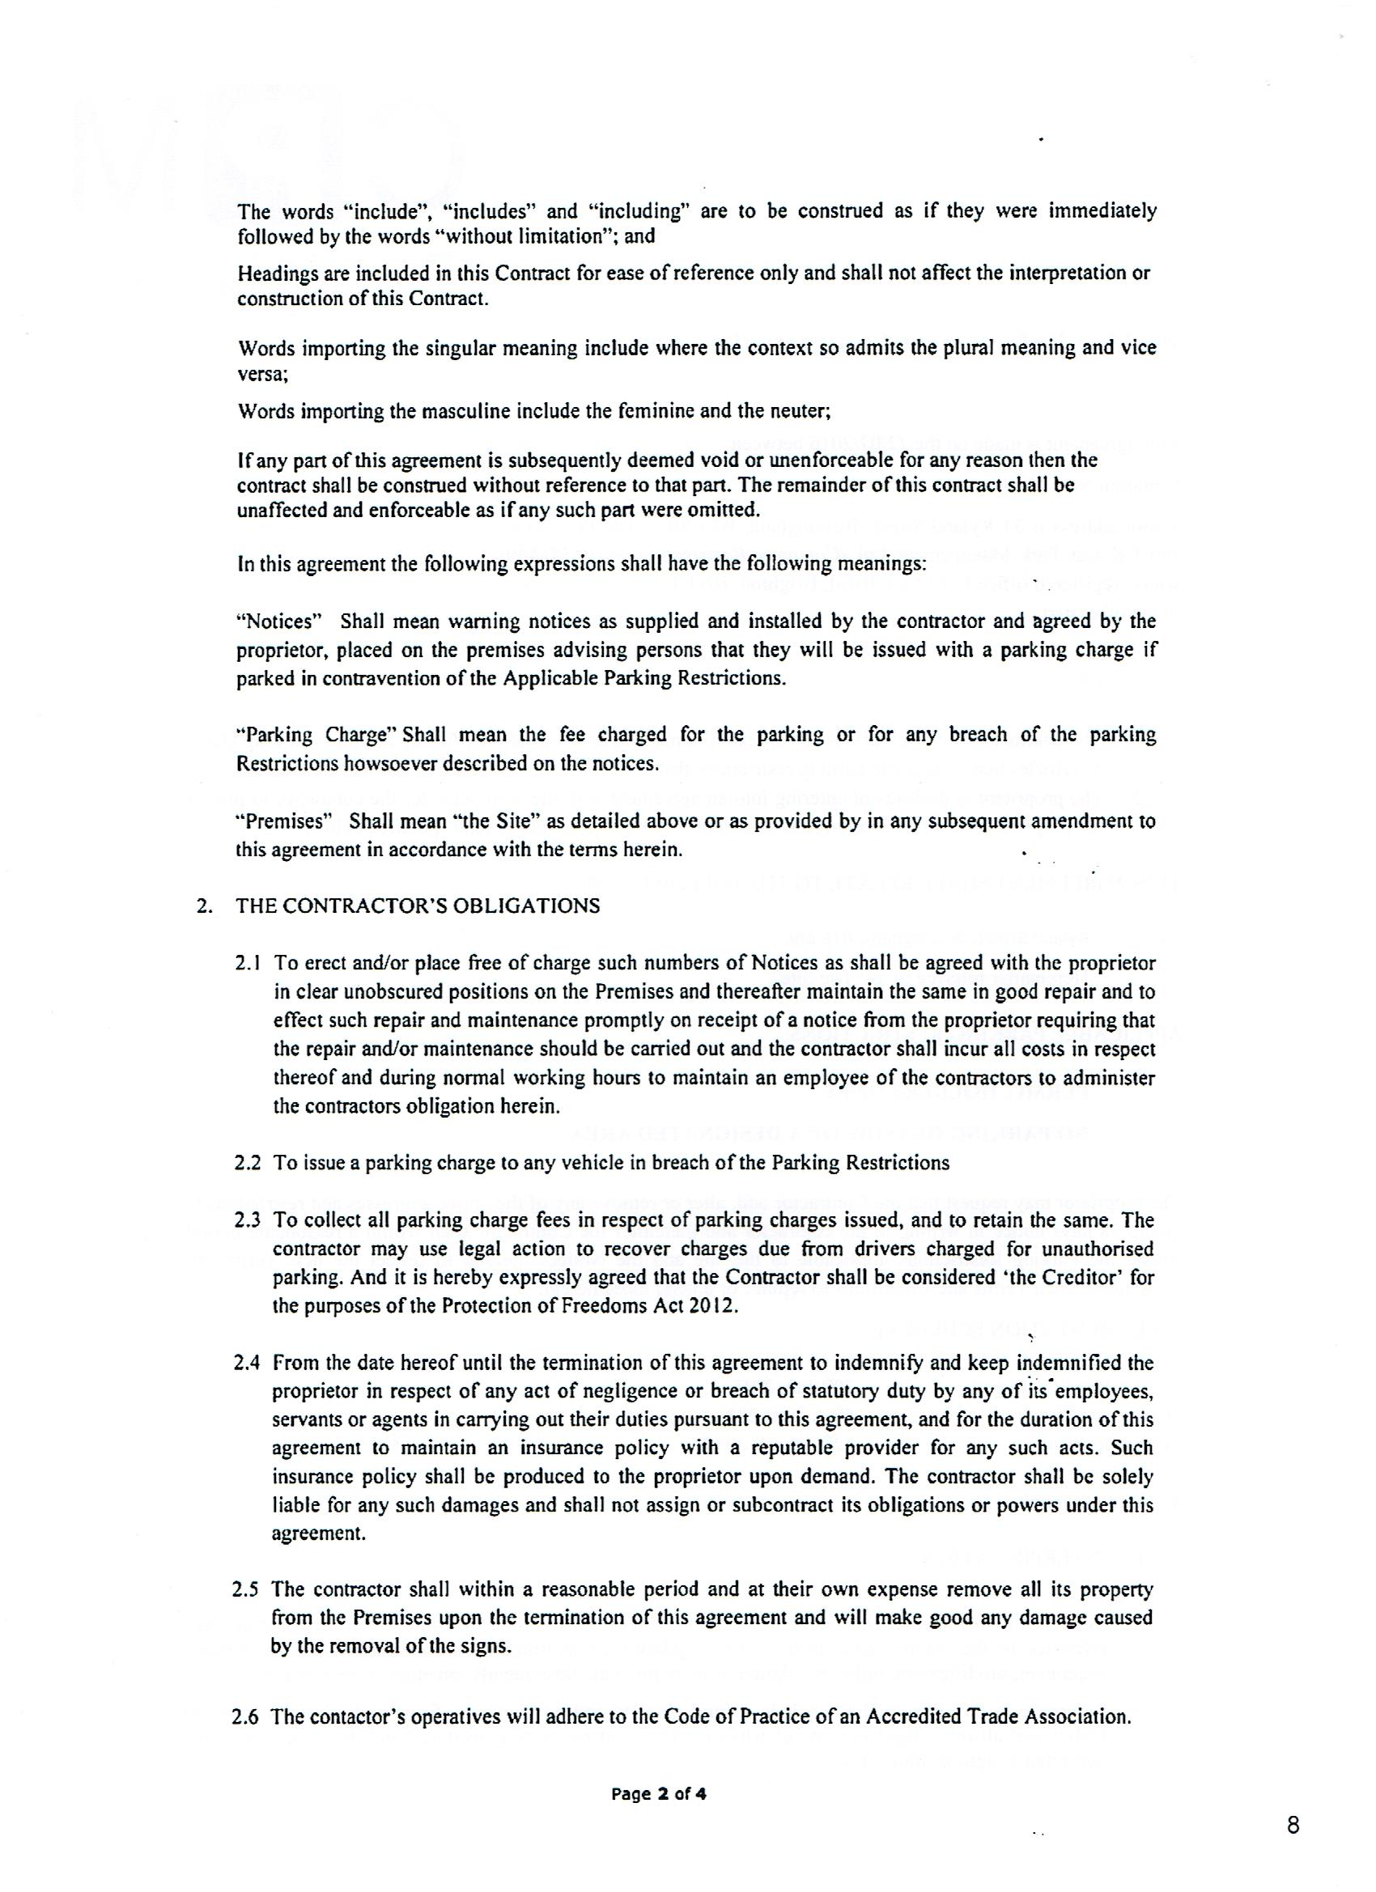

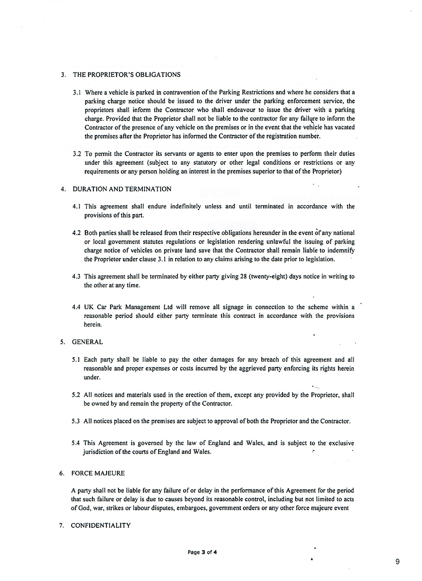

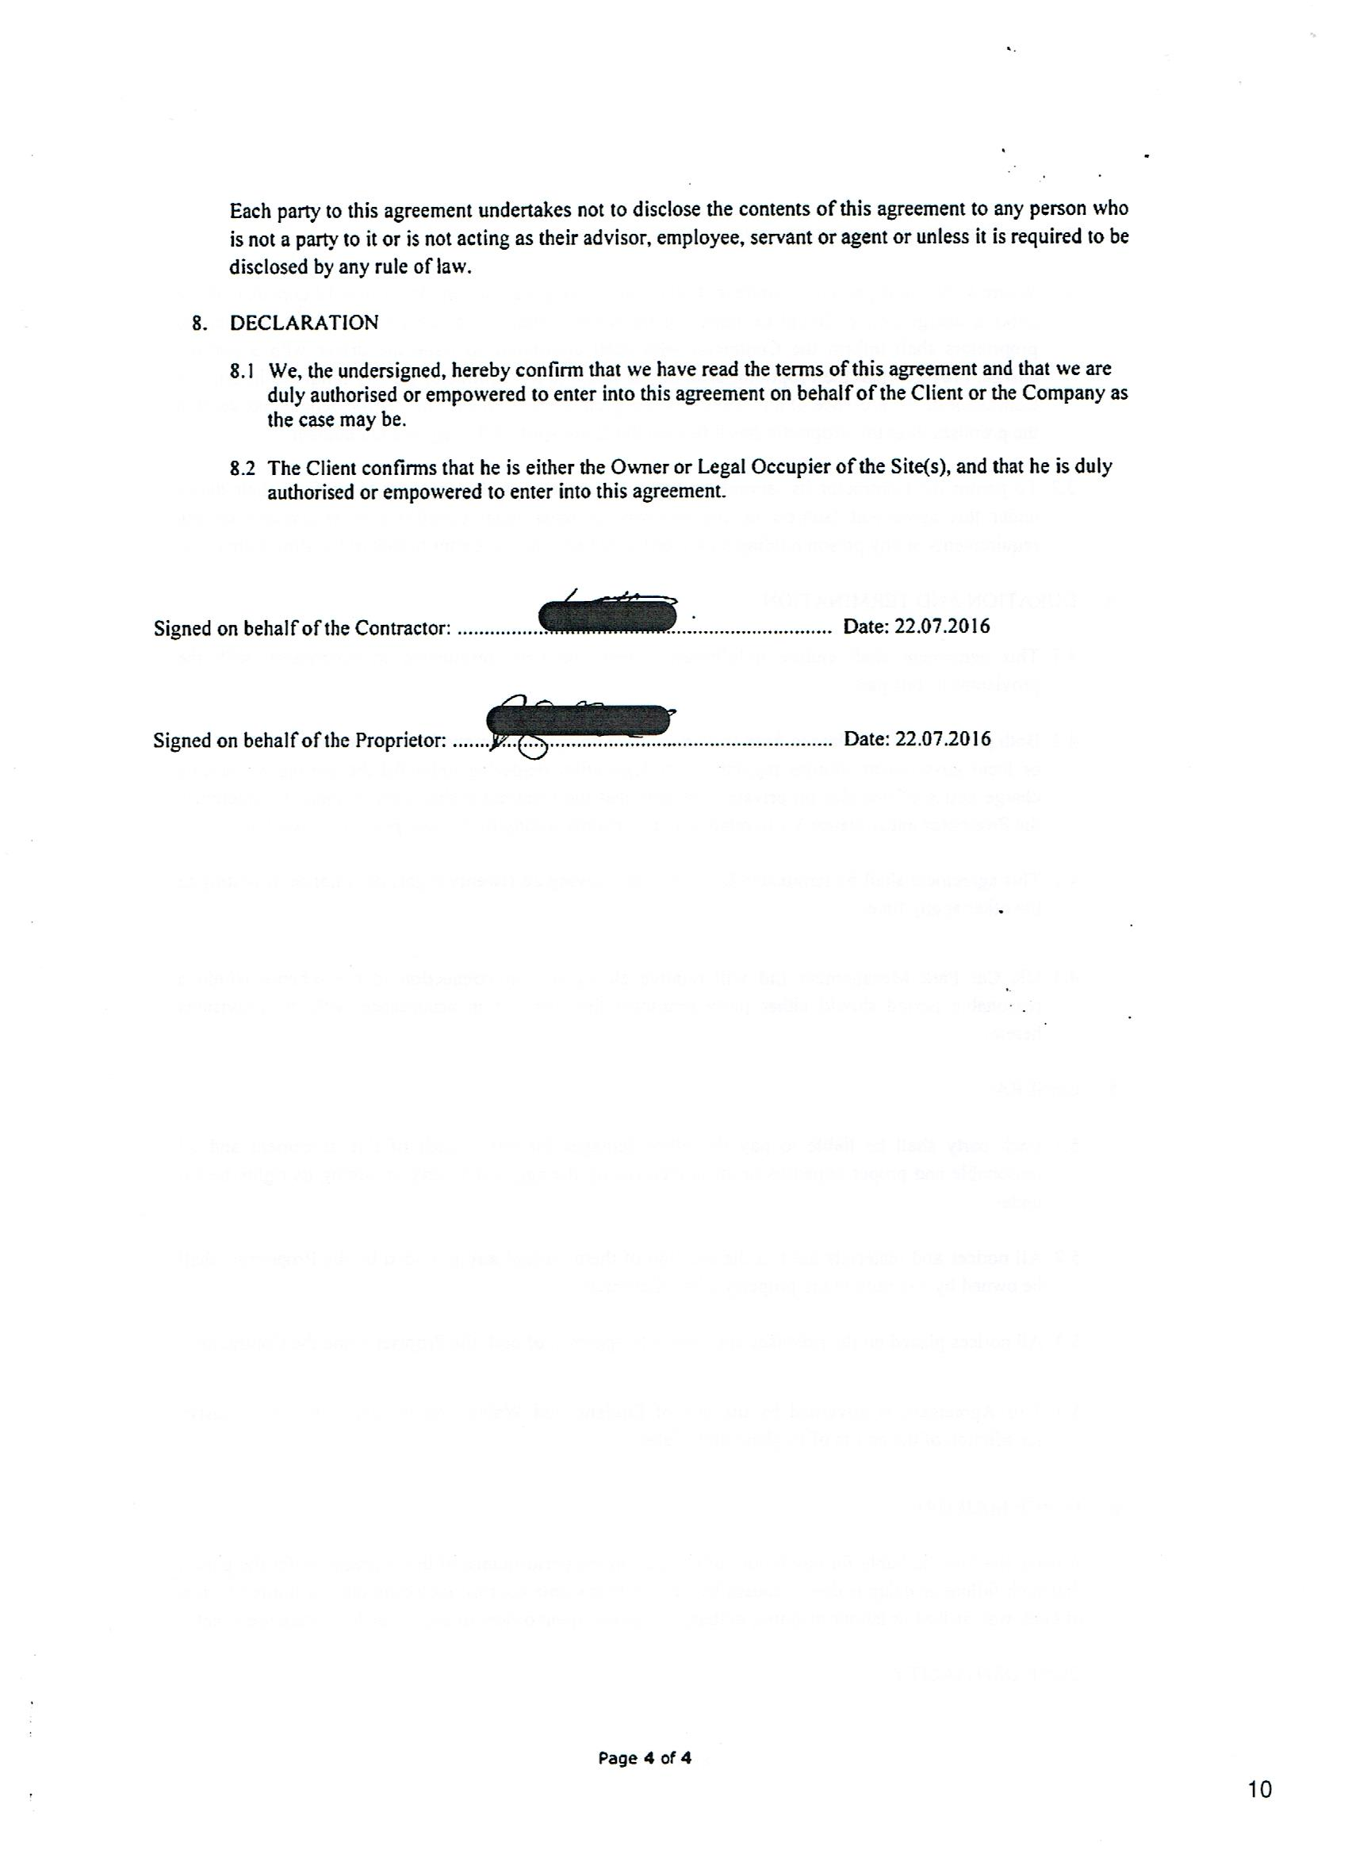

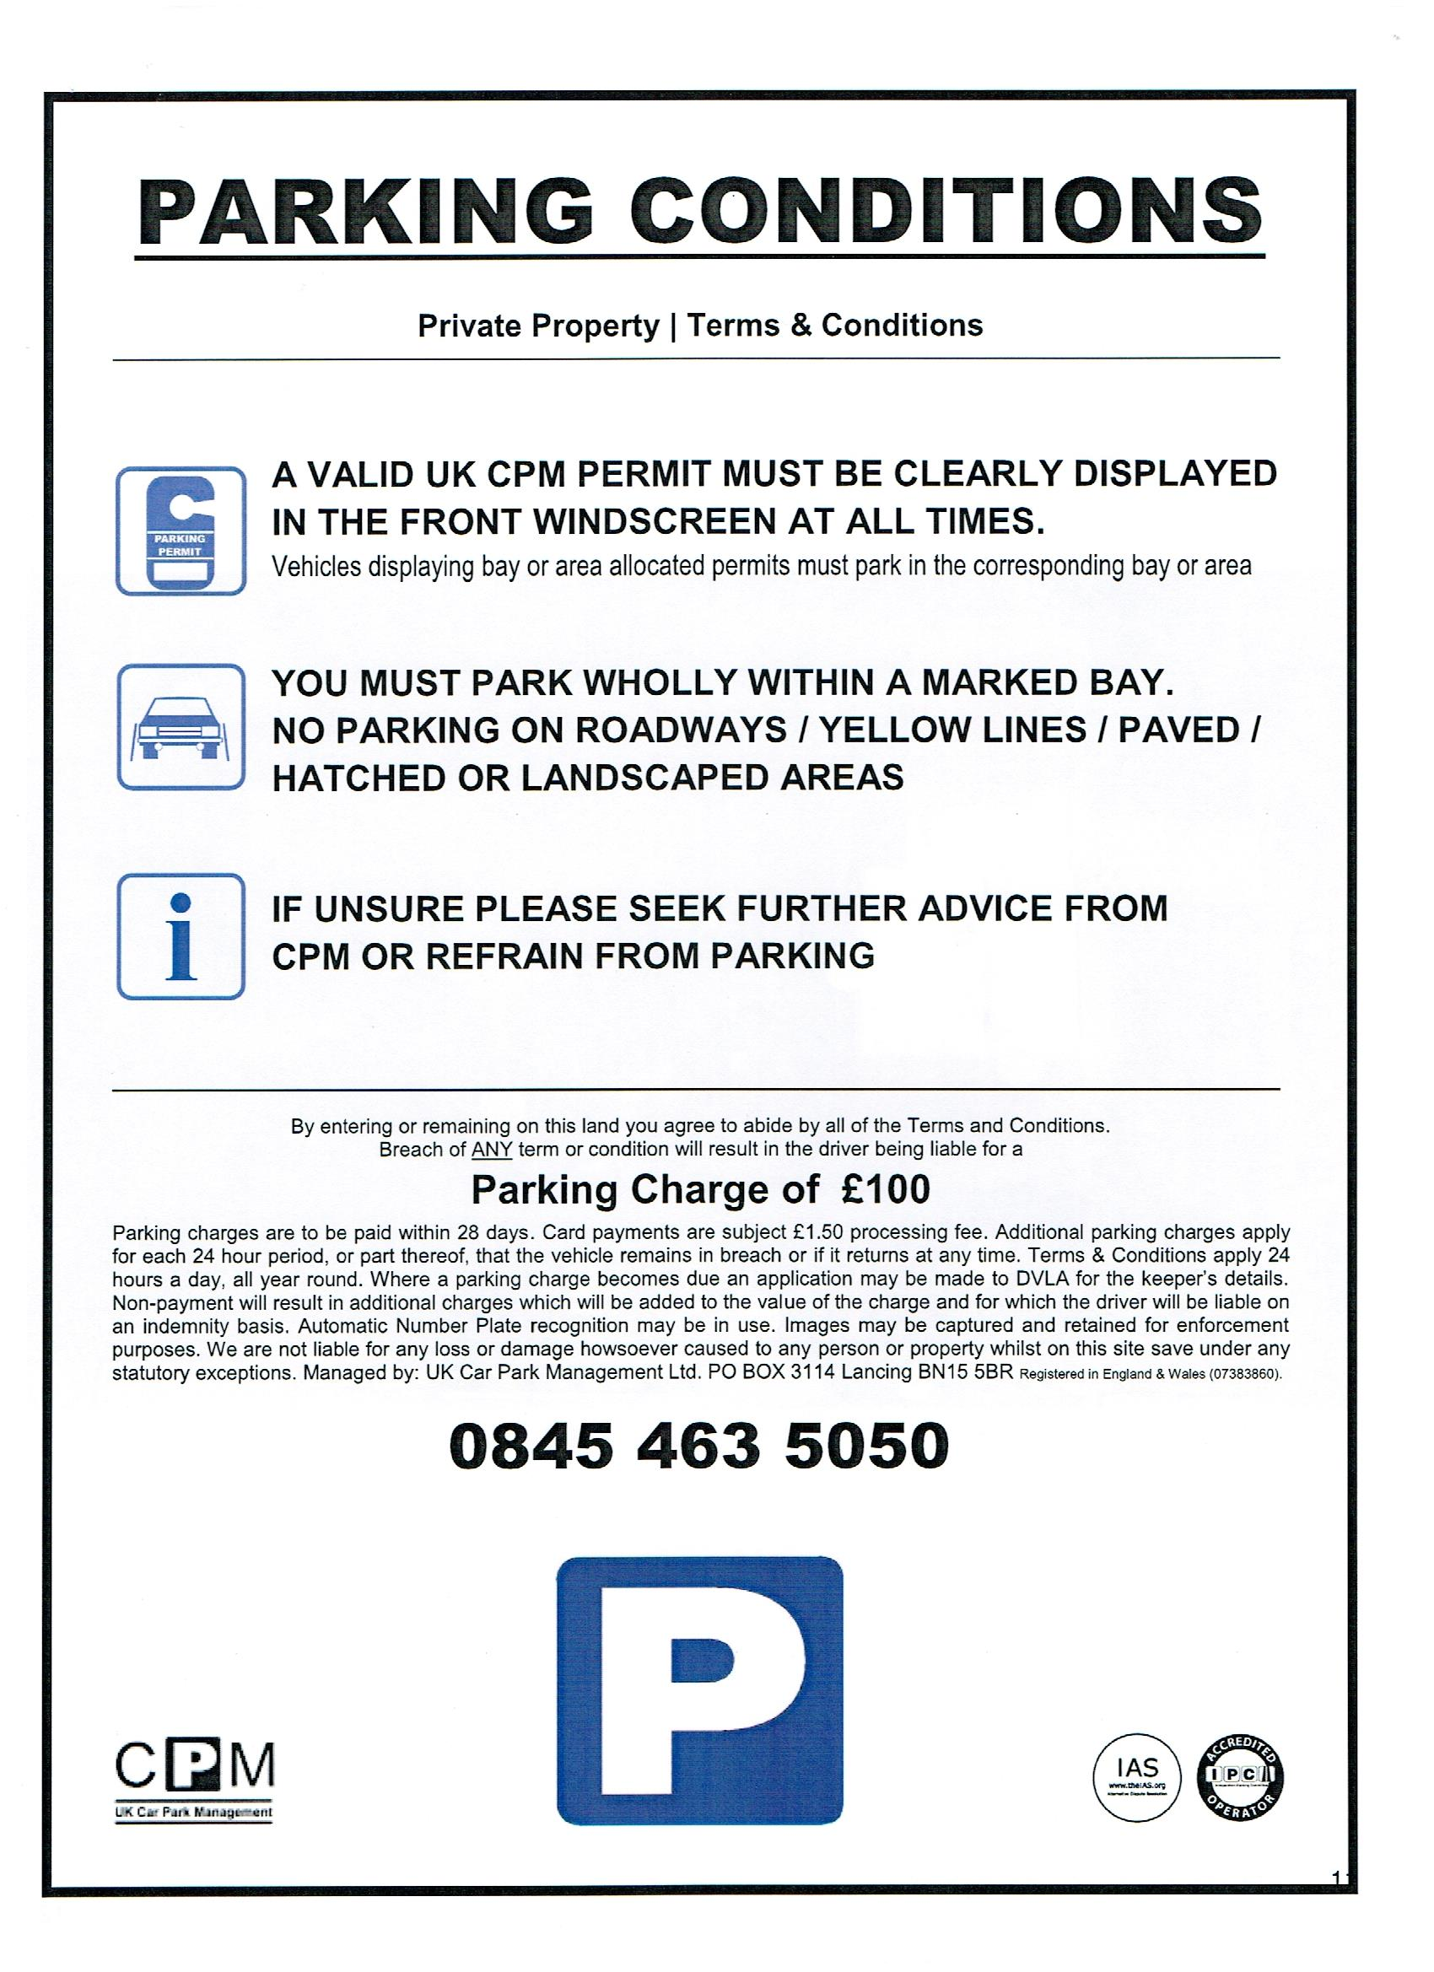

ORDER In District the Manchester Judge lyerCounty Court Case C7GF6E3Rnumber:

Parties Pace Recovery And Storage Ltd Claimant
Zoltan Lengyel Defendant

Warning: You must comply with the terms imposed upon you by this order otherwise your case is liable to be struck out or some other sanction imposed. If you cannot comply you are expected to make formal application to the court before any deadline imposed upon you expires.
On 24 May 2017
Before District Judge lyer at the Civil Justice Centre, Manchester without a hearing/at a paper hearing under CPR 27.9 rr WAS ORDERED that:
The Claimant's claim against the Defendant is dismissed for the reasons in the attached judgment.
STAFF
A copy of this order has been emailed to '3 0v.uk under the filename as below. It should be received (at the latest) by the morning after the date when the order was made. If you have not received it or if you have any questions, please inform District Judge lyer ASAPe
Pace Recovery And Storage Ltd v Zoltan Lengyel 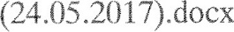
NOTES (not part of order)

IN THE COUNTY COURT (MANCHESTER) CASE NUMBER: C7GF6E3R
BETWEEN

PACE RECOVERY AND STORAGE LTD CLAIMANT

AND
ZOLTAN LENGYEL | DEFENDANT
JUDGMENT
1. This is a claim for unpaid parking charges under Schedule 4 to the Protection of Freedoms Act 2012. It has been allocated to the Small Claims Track and the parties have agreed that I should deal with it without a hearing, under CPR
0 On 21 April 2016. the Defendant parked his vehicle, a hired motor car, in the Fleming Road Car Park, London SE17 30Y He did not display a permit to park.
32 The Claimant, which manages the car park, considered that the Defendant had breached their terms and conditions and sent a parking charge notice to the hire company, which was passed onto the Defendantä
40 Paragraphs 13 to 14 of Schedule 4 allow a parking companv to recover unpaid parking charges from the hirer of a vehicle, where '*the driver of a vehicle is required by virtue of a relevant obligation to pay parking charges In respect of the parking of the vehicle on relevant land" and "those charges have not been paid in full ^{C}&: par. 1(1),
- By virtue of pare 1(2):
  - A "relevant obligation" means '*an obligation arising under the terms of a relevant contract" or, "where there is no relevant contract, as a result of a trespass or other tort committed by parking the vehicle on the relevant land". For the purposes of this claim, the Claimant relies on a "relevant contract".
b, A "relevant contract" means "a contract (including a contract arising only when the vehicle was parked on the relevant land) between the driver and a person who is - (a) the owner or occupier of the land, or (b) authorised, under or by virtue of arrangements made by the owner or occupier of the land, to enter into a contract with the driver requiring the payment of parking charges in respect of the parking of the vehicle on the land'
- I must therefore be satisfied that:
  - The Claimant had the authority of the owner or occupier of the site to enter into contracts with people who parked their cars in the car parke
  - The Claimant and the Defendant entered into such a contract.
  - It was a valid and enforceable contract,
If I am satisfied of these, I must further be satisfied that the Defendant was in breach of the terms of the contract to display a permit, though this is admitted, subject to the other requirements.
8, The Claimant has produced, as an exhibit to the witness statement of Michael Charman, its Director, a two-page agreement dated 113 September
Westcott (Southwark) Management Co. Ltd ("Westcotf*) which zives the
Claimant:
authoritv To begin issuing charge notices to vehicle oarked oar authority from the start date [i October 2012/
The agreement appears to have been drafted by the Claimant, and, in accordance with the "contra proferentem" rule, I must interpret any ambiguity against the Claimant.
9. This raises the first concern, which is that the language of this agreement does not specifically permit the Claimant to enter into contracts with driverso
- The agreement merely authorises the Claimant to "issue charge notices", which is quite different from "[entering] into a contract with the driver"
- The Claimant is not given the power to authorise parking; since that clearly remains vested in Westcott, by virtue of the words "parked without our authority". Without the power to authorise parking, the Claimant is unable to provide any contractual benefit to a driver.
I consider that the agreement amounts to nothing more than an agency agreement that allows the Claimant to issue charge notices on behalf of
Westcott (which would be for Westcott to sue upon) but no moree
1(). The second concern is about whether, even if I am wrong in the above, the Claimant did enter into a contract with the Defendant- Such a contract would be one which allowed the Defendant to park in the car park on the display of a valid permits As this would be a consumer contract, it must be "fair": 62 of the Consumer Rights Act 2015. As the Supreme Court held in Parkin E ^{y}e Ltd v Beavis [2013] EWCA Civ 1539 and [2015] EWCA Civ 402, the concept of fairness requires the parking firm to comply with the requirements of the relevant code of practice, being either the British Parking Association's code or the International Parking Committee-s code,
IL Pars 182 of the former provides:
Entrance signs play an important part in establishing a parking contract and deterring trespassers. Therefore, as well as the signs you must have telling drivers about the terms and conditions for parking, you must also have a
standard form of entrance sign at the entrance to the parking area.
Park 28.1 Drovides:
A driver who uses your private car park with your permission does so under a licence or contract with you. If they park without your permission this will usually be an act of trespass. In all cases, the driver 's use Q/your land will be governed by your terms and conditions, which the driver should be made aware offrom the start. You must use signs to make it easy fbr them to find out what your terms and conditions are.
Par. 2 of Part B of the latter provides:
2.1 Where the basis of your parking charges is based in the law of contrac/ i/ will usually be by way of the driver of a vehicle agreeing to contractual terms identified by signage in and around a controlled zone. it is therefore o/ fundamental importance that the signage meets the minimum standards under The Code as this underpins the validity of any such charge
22 Signs must conform to the requirements as set out in a schedule I to the
Code,
The recommended sign has a large image of the letter "P" with the words "Pay and Display" under it, though this can be adapted to different situations-
Part E states that such signs must:
Have clear and intelligible wording and be designed such that it is clear to the reasonable driver that he is entering into a contract with the creditor or committing a trestyass as the case mav be;
It is an important element of both of these that the signs inform the driver that he is entering into a contract with the Claimant.
12 The ClaimanCs sign has a large box with the words:
WARNING PRIVATE LAND
24 Hour Enforcement Zone
This site is managed and operated by Ace Securitv Services
Terms oncl Conditions
Vehicles must display a valid permit prominently and comply with any conditions on that permit;
Vehicles must not cause an obstruction to roadways, other road users, emergency access areas or bin areas.
The drive, by breaching any of the above Terms and Conditions while parking or remaining on this land, accepts liability för a
Charge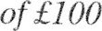
Payable within 28 days of issue. A driver who uses your private car park with your permission does so under a licence or contract with you. If they park without your permission this will usually be an act of trespass. In all cases; the driver 's use ofyour land will be governed by your lerms and condilions, which the driver should be made aware offrom the start. You must use signs to make it easy for them to find out what your terms and conditions are.
- Nowhere within this sign does it inform the reader that by parking in the car park, he is entering into a contract with the Claimant. Indeed, the words "contract" or "agreement*' do not appear at all within the sign, which merely refers to the driver "accepting liability for a charge". The phrase "terms and conditions" are not synonymous with a contract. Further, the opening words of the sign appear to be designed more to ward off trespassers than to enter into a contract with the driver. In the circumstances, I consider that the Defendant did not enter into a contract with the Claimant by parking his vehicle in the car park.
- The third concern is that, even if I am wrong about the Claimanüs authority and the sufficiency of the signage to advise drivers that they are entermg into a contract with the Claimant the contract requires the driver to display a parking permit, which is something that the Defendant says that he could not do, because he was visiting a resident of the apartments, Mr. Villons who the
Defendant says -was informed that his apartment was not one Uf chose eligible for a parking permit" (par& 5 of the Defendant-s witness statement), Slr é Villon has produced his own witness statement verifying thisc Insofar ihe Claimant's Mr- Charman's evidence suggests that Mr. Villon was provided with a permit, no details are offered, I note that the Claimant is not the company which distributes these, there is no evidence from Westcott that it gave Mrg Villon a permit, and I accept that no such permit was provided to him.
- The consequence of this is that any contract between the Claimant and the Defendant required the Defendant to do something which he simply could not do, that is, display a permit. His inability to do this was nol caused by any act or omission by the Defendant but by a state of affairs over which he had 110 control. Indeed, it must have been obvious to the Claimaßt that if it erected a sign proving that it was a term of the contract that the driver of any parked vehicle displays a permit, it must have known in advance that many drivers would simply be unable to do this. Therefore, insofar as there was any contract between the parties, it was invalid under the doctrine of impossibility of performance.
- It may be that the Claimant's claim may have more properly been phrased in trespass than in breach of contract but that is not something about which I need to speculate, since it is not the Claimant's case that the Defendant is liable as a trespasser$
17 e For these reasons, the Claimant's claim against the Defendant fails and is dismissed.
District Judge Iver
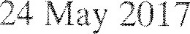

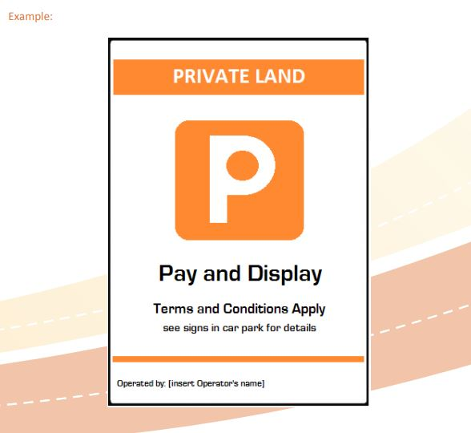

If this Transcript is to be reported or published, there is a requirement to ensure that no reporting restriction will be breached. This is particularly important in relation to any case involving a sexual offence, where the victim is guaranteed lifetime anonymity (Sexual Offences (Amendment) Act 1992), or where an order has been made in relation to a young person
This Transcript is Crown Copyright. It may not be reproduced in whole or in part other than in accordance with relevant licence or with the express consent of the Authority. All rights are reserved

IN THE SOUTHAMPTON COUNTY COURT No. F0DP806M
F0DP201T

Courts of Justice London Road, Southampton

Monday, 11 November 2019

Before:

DISTRICT JUDGE GRAND

B E T W E E N :

BRITANNIA PARKING GROUP LTD Claimant

- and -

(1)

Defendants
(2) CHRIS CROSBY

_________

MR H. MAINWARING (instructed by Messrs BW Law) appeared on behalf of the Claimant.

The First Defendant appeared in person.
MRS REEVES appeared on behalf of the Second Defendant.

[Transcript produced from poor quality audio recording – one channel working out of two]

__________

J U D G M E N T

THE DISTRICT JUDGE:

- I have two applications before me in two sets of proceedings although the applications are essentially the same. Both sets of proceedings were before District Judge Taylor in May of this year. They are both claims by Britannia Parking Group Ltd trading as Britannia Parking, one against Mr Chris Crosby and the other against Mr. Both relate to parking penalty charge notices issued against the respective defendants and both include in the claim a claim that is expressed in the claim form as a claim for £60 additional expenses pursuant to PCN terms and conditions.

- In response to both matters a defence has been put in – the defences are not identical – and the matter came before District Judge Taylor in box work for consideration with directions questionnaires, the matters having been transferred out of the money claims centre. In both matters he struck out the claims as an abuse of process, the reasons given being that the claimant claims a substantial charge additional to the parking charge, which it is alleged the defendants failed to pay; and that the additional charge is not recoverable under the
Protection of Freedoms Act 2012 Schedule 4 nor with reference to the judgment in Parking Eye v Beavis ; and that it is an abuse of process for the claimant to issue a knowingly inflated claim for an additional sum which it is not entitled to recover.

- Of course it also contained a notice pursuant to rule 3.3 that either party has the right to apply and that is exactly what the claimant has done in both cases. They have applied for District Judge Taylor’s order to be set aside and for directions to be given. In support of that, I have the statement of Colin Brown and a second statement from Colin Brown and I have had skeleton arguments today from Mr Mainwaring, counsel who appears on behalf of the claimant, and Mrs Reeves who is the lay representative for Mr Crosby.

- I have heard submissions from Mr Mainwaring, Mrs Reeves, and also very briefly from Mr.
who takes a very different position from Mr Crosby. I think it is probably fair to describe him today as almost a spectator in that he raised a defence under the Bills of Exchange Act but does not contest the parking charge and does not really resist the claimant’s application.

- What I should also mention is that when the claimant submitted its application, it requested that it be placed in front of a circuit judge. His Honour Judge Hughes QC is the designated civil judge for this area. He directed that the matter be listed with a time estimate of 30 minutes before a full time district judge which is what it has been, although it has overrun its time estimate. The skeleton arguments, with which I have been provided, can only be described as very full.

- All these parking cases now operate under the shadow of the Supreme Court decision of Parking Eye v Beavis. Prior to the Supreme Court’s decision in Parking Eye v Beavis there was litigation going on up and down the country around all sorts of issues which were raised by defendants but resisted by parking companies. The bringing of the case before the Supreme Court --- maybe I should not say it was intended to provide a definitive answer to the issues being raised, but certainly it was the hope that the decisions which were being made by the courts up and down the country would become very much simpler as a result of the matter going to the highest court in the land and that court giving a judgment. The charge in that case (Beavis) was £85. One may say it was disproportionate for such a case to go to the Supreme Court but the volume of cases and the amounts of money involved overall, led to that happening. Those challenging parking charges were to be disappointed
OPUS 2 DIGITAL TRANSCRIPTION 2

by the decision of the Supreme Court which essentially decided that the parking charges were not a penalty. They did that after careful consideration, and a lengthy case report of the judgments given was released.

- So it is against that background that we have this case before us. What the Supreme Court decided was that the charge of £85 as a parking charge was reasonable and acceptable, lawful, legitimate and entirely defensible and appropriate within the scheme of the regime of parking charges.

- The reason District Judge Taylor gave for striking out the claim in this case is that there is an additional substantial charge which the claimant in this case is seeking to make. He is criticised for giving very brief reasons for the strike out but in fact his reasons are substantially longer than the original particulars of claim which set out the additional parking charge of £60.

- It seems to me that there are two issues here; first of all, whether it is appropriate for the additional charge to be struck out and then, secondly, whether the striking out should take with it the whole of the claim or whether the court should strike out the £60 charge and leave outstanding the £100 charge which is within the bounds of what the Supreme Court considered reasonable in Parking Eye v Beavis.

- Mr Mainwaring on behalf of the claimant says that this is more a matter for evidence or substantial consideration at trial whereas Mrs Reeves on behalf of Mr Crosby cites a number of paragraphs from the Beavis judgment, suggesting that the Supreme Court decided that the charge of £85 for overstaying in a car park was reasonable but higher charges were not to be.

- It is difficult to do justice to absolutely everything which has been put before me in the skeleton arguments and the submissions today but I will deal with them, I hope, as clearly and as briefly as I can.

- Reference is made by the Claimant to the guidance provided by the British Parking
Association (and the British Parking Association code of practice was referred to in the Supreme Court decision of Parking Eye v Beavis). That judgment also refers to the statutory instrument which sets out what local authorities may charge by way of parking charges. It does seem to me that the Supreme Court gives a somewhat uncritical consideration of the BPA Code of Practice, in that the BPA is an association of parking companies. The guidance is produced by parking companies for parking companies largely for their own benefit. They refer to the fact that there is only one such association. So when the claimant asks me to look at the BPA Code of Practice, which says that a £60 charge is a reasonable charge to make, I treat it with massive scepticism because it seems to me that it is entirely self-serving for the British Parking Association to give guidance to parking companies of what are appropriate additional charges. I have much greater respect as I should to the Supreme Court decision about what is reasonable.

- I was taken by Mrs Reeves in her submissions to para.98 of Beavis where it is explained why the £85 charge is reasonable. It says that it has two main objectives; one is to manage the efficient use of parking spaces and this was to be achieved by deterring commuters or other long-stay motorists from occupying parking spaces for long periods. The other purpose was to provide an income stream to enable Parking Eye to meet the costs of operating the scheme and make a profit from its services. The judgment goes on at para.193 to say that the scheme also covered Parking Eye’s costs of operation and gave their shareholders a healthy annual profit.

- And again at para.198:

“The charge has to be and is set at a level which enables the managers to recover the costs of operating the scheme. It is here also set at a level enabling Parking Eye to make a profit.

- It seems to me absolutely clear from the Supreme Court judgment that what they were determining was what a reasonable charge was in the context of running these parking schemes. Some people will stay within the rules and will pay nothing or pay a small charge. Others will overstay and will pay much larger charges which the Supreme Court has found to be a proportionate and reasonable penalty. The Supreme Court considered a charge of £85 and determined that that is not an unacceptable charge.

- What we have here is essentially a charge of £160 for parking although the advertised figure for the charge on the signage is £100. The £60 is based on the vague additional sentence on the sign saying that there may be other charges. The particulars of claim then refer to this almost as an afterthought in that it comes as the last line after reference to the claim for interest. The claim form says it is £60 for contractual costs pursuant to the PCN and the terms and conditions. It seems to me that that the £60 charge is quite transparently an attempt to gild the lily, to garnish the margin of what is provided in the Supreme Court decision of Beavis as to what is a reasonable charge in the circumstances and, to use District Judge Taylor’s words, it is an inflated charge.

- It has been suggested to me by Mr Mainwaring that somehow it is an additional charge for additional expenses which are caused by people who do not pay. The Supreme Court was concerned with a case of somebody who did not pay. This was the whole nub of what the case was about and it does not seem to me that it is appropriate for the parking companies, having won in the case of Beavis decided by the Supreme Court for the reasons given then to try to add on an additional charge.

- It seems to me that it is absolutely clear from the Supreme Court decision that the intention was not for parking schemes to make charges for overstayers that amount to £160 or for there be one charge and then another substantial charge. Therefore what the claimant is seeking to do in this case is to charge far more to somebody who does not comply with the parking terms than was approved by the Supreme Court in Beavis. It does seem to me that the additional sum charged is unlawful.

- I should mention that Mrs Reeves has raised before me the Consumer Rights Act and the court’s responsibility under s71 to consider potentially unfair terms even if the issue is not raised by any of the parties. Mrs Reeves sought to take me to the Act and she has identified to me the three examples in schedule to the Act which she says makes this additional charge unfair. It is Schedule 2 to the Act which gives the examples of terms which may be regarded as unfair. Mrs Reeves refers to examples 6, 10 and 14. I have to say that it seems to me that Mrs Reeves is right to refer to them and even if I had not been with her on the question of the parking fine it does seem to me that these charges are unfair terms in that they fit the three examples of unfair terms.. The reference on the signs to charges seems to me simply to leave entirely to the discretion of the parking company what additional charges they may levy and is completely against the intention of the Consumer Rights Act legislation and the question of what terms are fair.

- Example term 14 says:

“A term which has the object or effect of giving the trader the discretion to decide the price payable under the contract after the consumer has become bound by it, where no price or method of determining the price is agreed when the consumer becomes bound.”

- That is bang on. It does not say that there will be an additional charge of £60. It just vaguely refers to further charges.

- I further say that the charge of £60 on a parking charge of £100 is 60 per cent which is disproportionate. So, I find that the charge falls foul of the decision of Beavis, it falls foul of the unfair contract terms provisions of the Consumer Rights Act and it is quite clearly not a lawful charge.

- It follows from that that I must come to consider whether striking out the whole claim is appropriate. The inclusion of the additional £60 charge is an attempt to go beyond the decision in Parking Eye v Beavis about what is reasonable and so not a penalty. The whole claim is tainted by it. Even if one treats it as separate from the parking charge, the claimant should have well known that it is not a charge which is lawful. The very fact that they bring a claim in these circumstances, it seems to me is an abuse of the process of the court. In saying that, I observe that with any claim which is put before the court, if a party does not put in a defence to the claim, then it is open to the claimant to enter a default judgment. I have no information about the numbers but I do not doubt that many default judgments are entered in cases containing these additional charges and the claimant then has the benefit of those judgments, including, as they do, additional charges which I have found to be unlawful. That reinforces why it is abusive to include unlawful additional charges in these claims.

- So I conclude by saying that I dismiss the application to set aside District Judge Taylor’s order.

__________

CERTIFICATE

Opus 2 International Limited hereby certifies that the above is an accurate and
complete record of the Judgment or part thereof.

Transcribed by Opus 2 International Limited
Official Court Reporters and Audio Transcribers
5 New Street Square, London, EC4A 3BF Tel: 020 7831 5627 Fax: 020 7831 7737
civil@opus2.digital

** This transcript has been approved by the Judge **

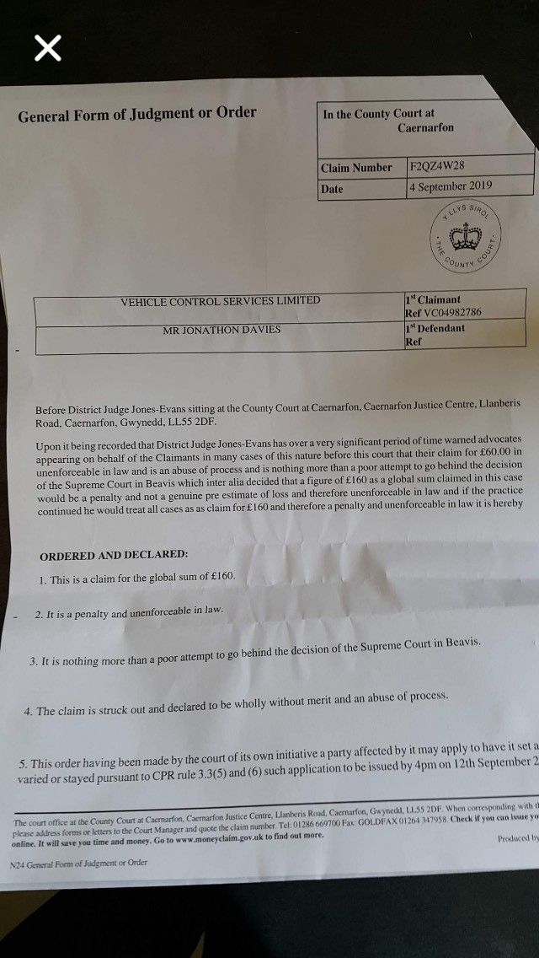

Defendant’s Schedule of Costs

