IN THE COUNTY COURT
Claim No.: xxxxxxxx

Between

NATIONAL CAR PARKS LIMITED
(Claimant)

-and-

Defendant (Defendant)

__________

DEFENCE
__________

- The Defendant denies that the Claimant is entitled to relief in the sum claimed, or at all. It is denied that the driver of the vehicle entered into any contractual agreement, whether express, implied, or by conduct, to pay a ‘parking charge’ to the Claimant.

- In relation to parking on private land, it is settled law from the Supreme Court, that a parking charge must be set at a level which includes recovery of the costs of operating a scheme. However, this Claimant is claiming a global sum of £160. This figure is a penalty, far exceeding the £85 parking charge in the ParkingEye Ltd v Beavis case.

- The global sum claimed is unconscionable and it was not shown in large lettering on any consumer signs, and it is averred that the charge offends against Schedule 2 of the Consumer Rights Act 2015 (‘the CRA’), where s71(2) creates a duty on the Court to consider the fairness of a consumer contract. The court’s attention is drawn (but not limited to) parts 6, 10, 14 and 18 of the list of terms that are likely to be unfair.

- Even if the Claimant had shown the global sum claimed in the largest font on clear and prominent signs - which is denied - they are attempting double recovery of costs. The sum exceeds the maximum amount which can be recovered from a registered keeper, as prescribed in Schedule 4, Section 4(5) of the Protection of Freedoms Act 2012 (‘the POFA’). It is worth noting that in the Beavis case where the driver was known, the Supreme Court considered and referred more than once to the POFA.

- Claims pleaded on this basis by multiple parking firms have routinely been struck out ab initio in various County Court areas in England and Wales since 2019. Recent examples are appended to this defence; a February 2020 Order from District Judge Fay Wright, sitting at Skipton County Court (Appendix A) and a similar Order from Deputy District Judge Josephs, sitting at Warwick County Court (Appendix B).

- Applications by AOS member parking firms to try to reach the usually low threshold to set aside multiple strike-out orders have been reviewed by more than one area Circuit Judge, including His Honour Iain Hughes QC, occasioning District Judge Grand at Southampton to hear submissions from a barrister on 11th November 2019. The court refused to set aside the Orders and, tellingly, no appeal was made.

- The Judge found that the claims - both trying to claim £160, with some ten or more similar cases stayed - represented an abuse of process that ‘tainted’ each claim. It was held to be not in the public interest for a court to let such claims proceed and merely disallow £60 in a case-by-case basis, thus restricting and reserving the proper application of the relevant consumer rights legislation only for those relatively few consumers who reach hearing stage. That Judgment is appended (Appendix C).

- The CCBC and/or the allocated Court Judge is invited to read the Appendices at the earliest opportunity. The Defendant avers that parking firm claims which add a duplicitous ‘costs’ sum to the parking charge are now easily identified to be unlawful. Such claims are against the public interest, requiring no further assessment, and listing such cases for trial should be avoided. The Court is invited to exercise its case management powers pursuant to CPR 3.4 to strike out this claim, which is entirely tainted by abuse of process and breaches of the CRA.

- Should this claim continue, the Claimant will no doubt try to mislead the court by pointing to their Trade Association ‘ATA’ Code of Practice (‘CoP’) that now includes a hastily-added clause 'allowing' added costs/damages. The Defendant points out that the CoP is a self-serving document, written in the parking firms’ interests. Further, the ‘admin fee’ model was reportedly invented by a member of the British Parking Association Board, Gary Osner, whose previous firm, Roxburghe (UK) Limited, folded after being declared ‘unfit’ by the Office of Fair Trading who refused to renew their consumer credit licence due to ‘unfair and misleading’ business practices. Mr Osner states in an article that has been in the public domain since 2018: ''I created the model of ‘admin fees’ for debt recovery because ticket value was so low that nobody would make any money. Parking is business and business is about money, after all.''

- The two competing ‘race to the bottom’ ATAs have engineered a veil of legitimacy to protect this industry for too long. They are not regulators and have failed consumers so badly, that Parliament is currently working on replacing them with a new CoP overseen by the Secretary of State, following the enactment of the Parking (Code of Practice) Act 2019. Many courts have now recognised that a predatory parking firm Claimant using unfair and predatory business practices and inflating their claims with false ‘admin fees’, is not the ‘innocent party’ in a dispute. In stark contrast to the BPA Board member’s mindset, the will of Parliament as set out in the new 2019 Act is very much consumer-focussed, aiming for: ''good practice...in the operation or management of private parking facilities as appears to the Secretary of State to be desirable having regard to the interests of persons using such facilities.''

- In the alternative, the defence is prejudiced and the court is invited to note that, contrary to the Pre-Action Protocol for Debt Claims, the Letter Before Claim omitted evidence of any breach and failed to append the wording of the sign or consumer notice. Further, the Particulars of Claim are embarrassing and incoherent, lacking specificity re the location of the event and status of the contracting parties and failing to detail any conduct or liability that could give rise to a cause of action. There is insufficient detail to ascertain the nature, basis and facts of the case but the sum claimed includes unrecoverable costs/damages and is clearly an abuse of process.

- The court is invited to note that the Beavis case would not have passed had it been pleaded in damages by ParkingEye, and the penalty rule applies to charges that are penal or unconscionable in their construction. The Supreme Court held at [14] ‘‘where a contract contains an obligation on one party to perform an act, and also provides that, if he does not perform it, he will pay the other party a specified sum of money, the obligation to pay the specified sum is a secondary obligation which is capable of being a penalty.’’ And at [99] ‘‘the penalty rule is plainly engaged.’’

- Unlike in this case, ParkingEye demonstrated a commercial justification for their £85 parking charge which included all operational costs and was constructed in such a way and offered on such ‘brief and clear’ signs with terms set in the interests of the landowner, that they were able to overcome the real possibility of the charge being struck out as penal and unrecoverable. The unintended consequence is that, rather than persuade courts considering other cases that all parking charges are automatically justified, the Beavis case facts and pleadings set a high bar that other claims fail to reach. Unusually for this industry, it is worth noting that ParkingEye do not add false ‘debt letter costs/damages’ to their parking charges and as a consequence, their own claims have escaped any reports of being summarily struck out.

- This Claimant has failed to plead their case, or to set out their terms or construct their contractual charges in the same way as in Beavis and the penalty rule remains firmly engaged. Paraphrasing from the Supreme Court, deterrence is likely to be penal if there is a lack of an overriding legitimate interest in performance extending beyond the prospect of compensation flowing directly from the alleged breach. The intention cannot be to punish drivers nor to present a motorist with concealed pitfalls or traps, nor to claim an unconscionable total sum.

- Should this poorly pleaded claim not be summarily struck out for any/all of the reasons stated above, the Defendant sets out this defence as clearly as possible in the circumstances, insofar as the facts below are known.

- The Defendant is the main driver of this vehicle and has knowledge of any parking charge notice (‘PCN’) or letters. It is not accepted that the location included prominent signs giving ‘adequate notice’ of the onerous parking charge. A compliant Notice to Keeper (‘NTK’) was not properly served in strict accordance with section 8 or 9 (as the case may be) of the POFA.

- The Claimants’ claim is based upon an ANPR from 06/06/19. The time of entry stated on the NTK is 10:43:15 and the time of exit is 11:47:50, a total of 1 hour 4 minutes and 35 seconds. The driver has a record of purchase from XXXX Bank, for a ticket within this time frame for an amount of £4. This would allocate a window of one to two hours parking within the establishment, as outlined on the Claimants website.

- When the driver entered the establishment via the entry point as seen on the ANPR photograph there were a number of vehicles in a queue waiting to park. Once the driver was able to park, within a matter of minutes, the driver then walked to acquire a ticket from one of the two machines located on the far side of the car park. One of the two available machines was faulty and there was a queue of people waiting to use the functioning machine. The driver was able to purchase a ticket for one to two hours, at the price of £4. This transaction was made using a XXXX credit card and the transaction receipt is held with XXXX Bank.

- The Claimant’s signs have vague/hidden terms and a mix of small font, such that they would be considered incapable of binding any person reading them under common contract law, and would also be considered void pursuant to Schedule 2 of the CRA. Consequently, it is the Defendant’s position that no contract to pay an onerous penalty was entered into with the Claimant, whether express, implied, or by conduct.

- The Beavis case is fully distinguished and a more relevant list of binding Court of Appeal authorities which are on all fours with a case involving unclear terms and a lack of ‘adequate notice’ of an onerous parking charge, would include:
(i) Spurling v Bradshaw [1956] 1 WLR 461 and (ii) Thornton v Shoe Lane Parking Ltd [1970] EWCA Civ 2, both leading examples of the ‘red hand’ rule - i.e. that an unseen/hidden clause cannot be incorporated after a contract has been concluded; and
(iii) Vine v London Borough of Waltham Forest: CA 5 Apr 2000, where the Court of Appeal held that it was unsurprising that the appellant did not see the sign ''in view of the absence of any notice on the wall opposite the southern parking space''.

- Further and in the alternative, the Claimant is put to strict proof that it has sufficient proprietary interest in the land, or the necessary landowner authorisation to issue PCNs under these circumstances and to pursue keepers by means of civil litigation. It is not accepted that the Claimant has adhered to the landholder's definitions, exemptions, grace period, other terms (or instructions to cancel charges due to a surge of complaints) and there is no evidence that the freeholder authorises this particular Claimant (Companies House lists their company number as 00253240). Any purported landowner 'contract' which fails to properly identify the two contracting parties and/or which is in any way redacted (including the signatories, which in some parking claims have been revealed not to be that of the landowner) should be disregarded, along with any undated and/or unsubstantiated records, documents, boundary maps or aerial views, or photos which are capable of manipulation.

- For any or all of the reasons stated above, the Court is invited to dismiss this claim.

- In the matter of costs. If the claim is not struck out, the Defendant seeks:
(a) standard witness costs for attendance at Court, pursuant to CPR 27.14, and
(b) the Court to reserve, assess and award the Defendant’s Summary Costs Assessment, to be filed and served at Witness Statement stage in anticipation of a typical late Notice of Discontinuance (‘NoD’) from this Claimant.

- At NoD stage, or at a hearing if the case proceeds that far, the Court will be taken to facts to support a finding of wholly unreasonable conduct by this Claimant. Pursuant to CPR 46.5, whilst indemnity costs cannot exceed two thirds of the applicable rate if using legal representation, the Defendant notes that LiP costs are not necessarily capped at £19 ph. The Defendant will ask for a fairly assessed rate for the hours spent on this case, referencing Spencer & anor v Paul Jones Financial Services Ltd.

- In summary, the Claimant's Particulars disclose no legal basis for the sum claimed. This Claimant knew, or should have known, that an exaggerated ‘parking charge’ claim where the alleged ‘debt’ exceeds the £100 ATA CoP ceiling is disallowed under the CPRs, the Beavis case, the POFA and the CRA, The Judge in the instant case is taken to the Appendices, demonstrating that several court areas continue to summarily strike out private parking cases that include an extravagant and unlawful costs sum.

Statement of Truth
I believe that the facts stated in this Defence are true.

Defendant’s signature: …………………………….…………………………….
Defendant’s name: …………………………….…………………………….
Date: …………………………….…………………………….

Appendix A attached: Order to strike out a similar claim; abuse of process (Skipton)
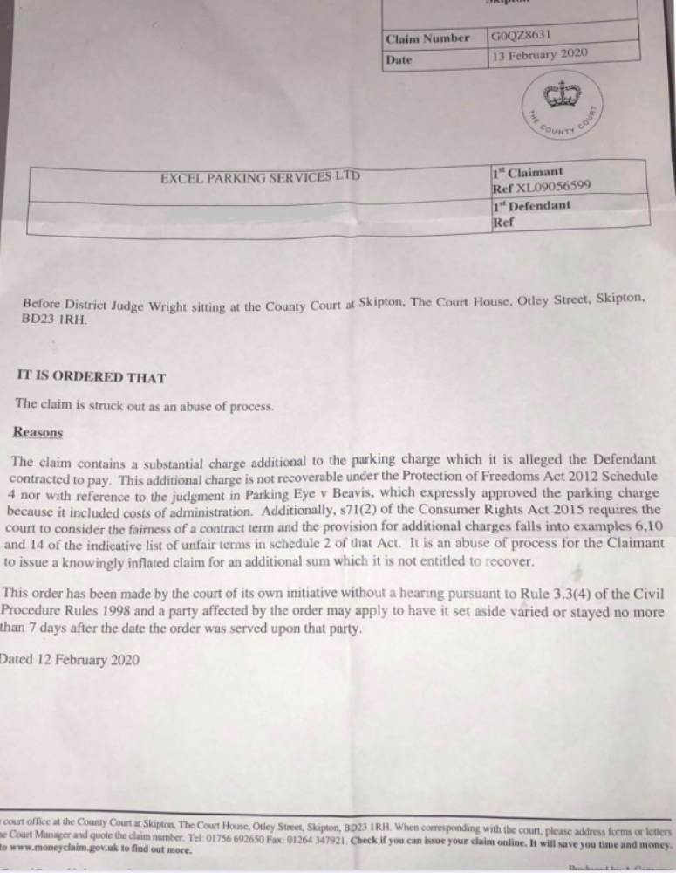
Appendix B attached: Order to strike out a similar claim; abuse of process (Warwick)
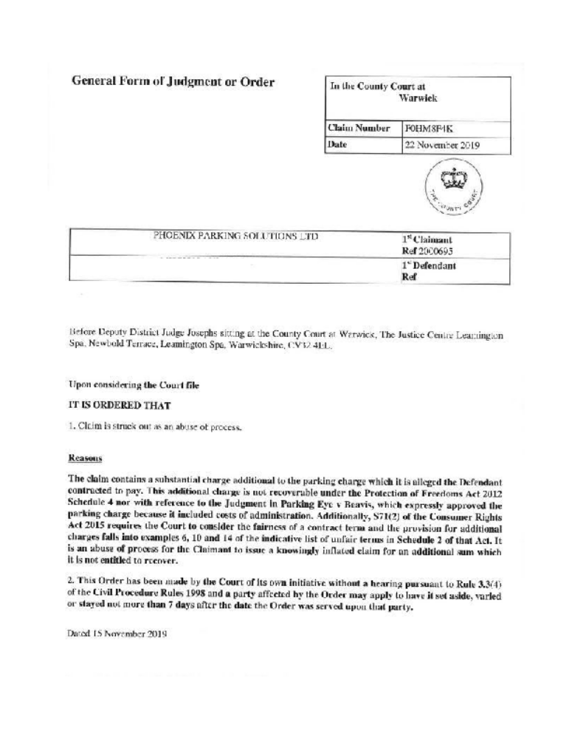

Appendix C: Judgment and reasoning for refusal to set aside Order (Southampton)
