POPLA Ref No.xxxxxxxx

I am the registered keeper and I wish to appeal a recent parking charge from Parking Eye Ltd. The charge is levied despite the driver not being identified.

The driver entered the carpark, got out the car to read the signs and pay for their parking. The driver then noticed the two payment machines onsite were not working. The driver then inspected signage relating to parking terms and conditions (see image 1). Having spent a number of minutes attempting to digest an unreasonable amount of information and concluding that without immediate internet access there was no further means to pay the driver got back into their car and left the car park. The vehicle entered the car park on the 22/09/20 at 16.42 and left at 16.49. This is a total of 7 minutes.
Parking Eye Ltd are essentially triggering a contract between themselves and the driver before payment is being made by capturing an image of a vehicle entering the site regardless of whether the driver is able to commence this agreement or not. In this case it was not possible to as both payment machines were not working.
I expect ParkingEye to provide strict proof that the PDT machines were in working order during the times specified in the PCN that was received by the registered keeper. Also ParkingEye need to provide evidence of PDT repairs for the day in question.

I refer you to the new statutory Code of Practice draft that will require at least 10 minutes consideration period plus enough time to leave, if the machines are all broken.

In relation to the Beavis case, the driver here cannot be considered to have 'agreed' to a parking contract like Mr Beavis did. An unfair 'out of all proportion' charge for non-parking activity is precisely the sort of charge that the Beavis case Judges made clear would fail the penalty rule which was 'plainly engaged'.

In relation to grace periods they are designed for the motorist to decide to enter into a legal contract by agreeing to purchase a ticket but cannot be suitable for purpose if there is no reasonable way of obtaining one due to ticket machines not working. Therefore the minimum 5 minutes grace period in this case cannot be fit for purpose.
British Parking Association Code of Practice 13.1 – 13.4 states:
Consideration and Grace Periods

13.1 The driver must have the chance to consider the Terms and Conditions before entering into the ‘parking contract’ with you. If, having had that opportunity, the driver decides not to park but chooses to leave the car park, you must provide them with a reasonable consideration period to leave, before the driver can be bound by your parking contract. The amount of time in these instances will vary dependant on site size and type but it must be a minimum of 5 minutes.

13.2 The reference to a consideration period in 13.1 shall not apply where a parking event takes place.

13.3 Where a parking location is one where a limited period of parking is permitted, or where drivers contract to park for a defined period and pay for that service in advance (Pay & Display), this would be considered as a parking event and a Grace Period of at least 10 minutes must be added to the end of a parking event before you issue a PCN.

13.4 Unauthorised motorists will not be entitled to the minimum time period of 5 minutes for a consideration period in spaces designated for specific users e.g Blue Badge holders, pick up/drop off or where parking is prohibited such as hatched areas in front of emergency exits, or on entry and exit ramps etc.

13.5 You must tell us the specific consideration/grace period at a site if our compliance team or our agents ask what it is.

13.6 Neither a consideration period or a grace period are periods of free parking and there is no requirement for you to offer an additional allowance on top of a consideration or grace period.
The operator makes much of Beavis case. They are well aware that the circumstances of the Beavis case were entirely different, essentially that case was the abuse of a free time limited public car park where signage could be used to create a contract.

In this case, the driver entered the car park, got out of their car to read the signs, saw the ticket machine was not working and therefore chose not to park in the car park. The driver did not accept any contract and therefore could not have breached the contract as Parkingeye have claimed. The driver stayed in the car park for less than 10 minutes in total, which is less than the grace period that the driver was entitled to under 13.4 of British Parking Association Code of Practice.

No evidence of Landowner Authority.
The operator is put to strict proof of full compliance with the BPA Code of Practice
As this operator does not have proprietary interest in the land then I require that they produce an unredacted copy of the contract with the landowner. The contract and any 'site agreement' or 'User Manual' setting out details including exemptions - such as any 'genuine customer' or 'genuine resident' exemptions or any site occupier's 'right of veto' charge cancellation rights - is key evidence to define what this operator is authorised to do and any circumstances where the landowner/firms on site in fact have a right to cancellation of a charge. It cannot be assumed, just because an agent is contracted to merely put some signs up and issue Parking Charge Notices, that the agent is also authorised to make contracts with all or any category of visiting drivers and/or to enforce the charge in court in their own name (legal action regarding land use disputes generally being a matter for a landowner only).
Witness statements are not sound evidence of the above, often being pre-signed, generic documents not even identifying the case in hand or even the site rules. A witness statement might in some cases be accepted by POPLA but in this case I suggest it is unlikely to sufficiently evidence the definition of the services provided by each party to the agreement. Nor would it define vital information such as charging days/times, any exemption clauses, grace periods (which I believe may be longer than the bare minimum times set out in the BPA CoP) and basic information such as the land boundary and bays where enforcement applies/does not apply. Not forgetting evidence of the various restrictions which the landowner has authorised can give rise to a charge and of course, how much the landowner authorises this agent to charge (which cannot
be assumed to be the sum on a sign because template private parking terms and sums have been known not to match the actual landowner agreement).
Paragraph 7 of the BPA Code of Practice defines the mandatory requirements and I put this operator to strict proof of full compliance:
7.2 If the operator wishes to take legal action on any outstanding parking charges, they must ensure that they have the written authority of the landowner (or their appointed agent) prior to legal action being taken.
7.3 The written authorisation must also set out:
a the definition of the land on which you may operate, so that the boundaries of the land can be clearly defined
b any conditions or restrictions on parking control and enforcement operations, including any restrictions on hours of operation
c any conditions or restrictions on the types of vehicles that may, or may not, be subject to parking control and enforcement
d who has the responsibility for putting up and maintaining signs
e the definition of the services provided by each party to the agreement
Also Parking Eye have provided no evidence that the ANPR system is reliable. The operator is obliged to ensure their ANPR equipment is maintained as described in paragraph 21.3 of the British Parking Association's Approved Operator Scheme Code of Practice. I require the Operator to present records as to the dates and times of when the cameras at this car park were checked, adjusted, calibrated, synchronised with the timer which stamps the photos and generally maintained to ensure the accuracy of the dates and times of any ANPR images. This is important because the entirety of the charge is founded on two images purporting to show the vehicle entering and exiting at specific times. It is vital that this Operator must produce evidence in response to these points and explain to POPLA how their system differs (if at all) from the flawed ANPR system which was wholly responsible for the court loss by the Operator in Parking Eye v Fox-Jones on 8 Nov 2013. That case was dismissed
when the judge said the evidence from the Operator was 'fundamentally flawed' as the synchronisation of the camera pictures with the timer had been called into question and the operator could not rebut the point.
Parking Eye has not provided any evidence to show that their system is reliable, accurate or maintained.

Unclear signage.
In reference to Image 1,and as shown in image 2, there are no marked bays anywhere onsite at the location nor boundary of the venue.
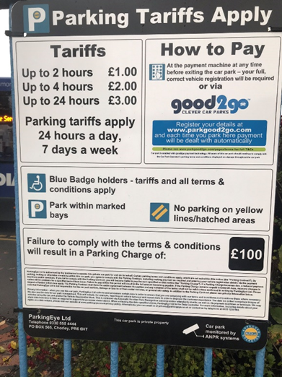
Image 2,
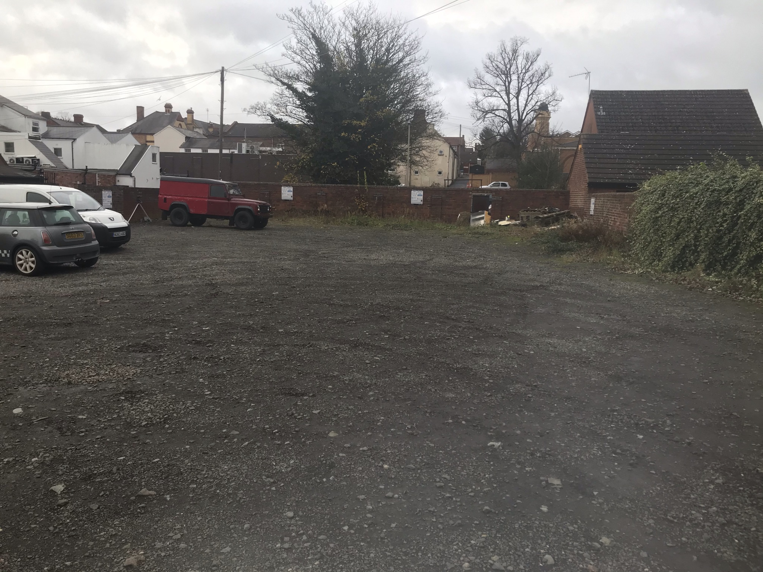

BPA’s Code of Practice (18.3) states:
“Signs must be conspicuous and legible, and written in intelligible language, so that they are easy to see, read and understand.”
BPA’s Code of Practice (Appendix states:
“Signs should be readable and understandable at all times, including during the hours of darkness or at dusk if and when parking enforcement activity takes place at those times. This can be achieved in a variety of ways such as by direct lighting or by using the lighting for the parking area. If the sign itself is not directly or indirectly lit, we suggest that it should be made of a retro-reflective material”

Image 3 below shows the only entrance to the Pedmore Road Car Park. ParkingEye issue fines against spaces beyond this point.
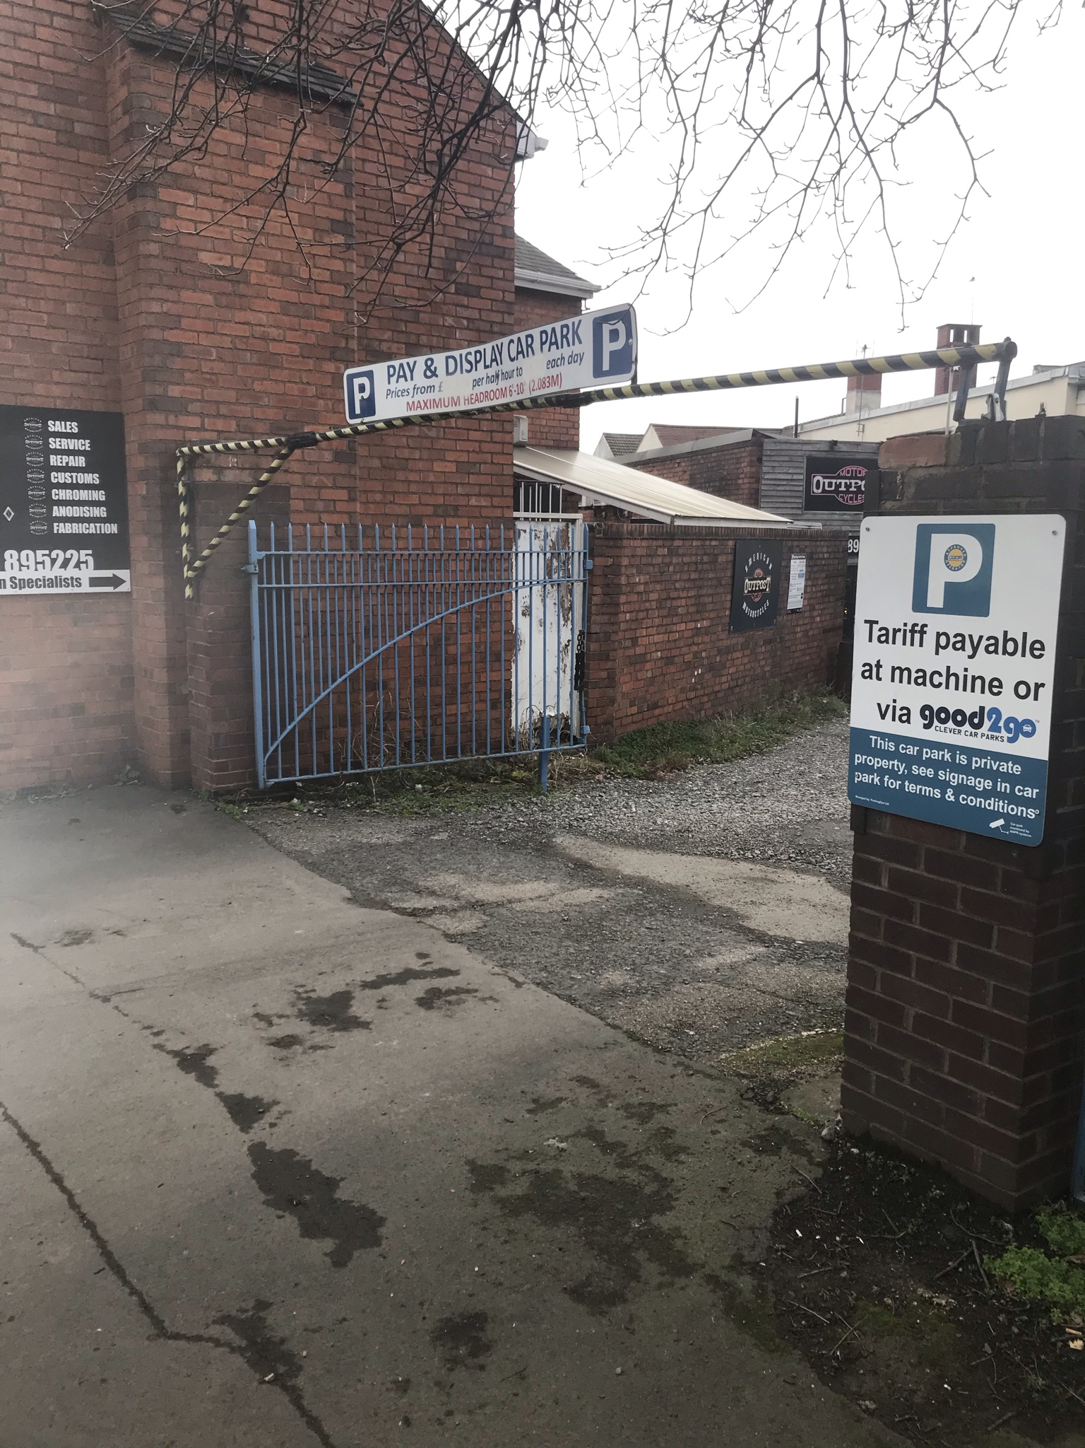
All vehicles passing through this point can be potentially captured by the ANPR and recorded an entry and exit time that are interpreted by ParkingEye Ltd the “parking time”.

ParkingEye’s signage within the car park is inadequate and illegible in a number of ways, not least because of the sheer amount of text that must be read. It clearly violates BPA’s Code of Practice (18.3) and appendix B.

Image 1 shows a close up of a car parking sign in the same lighting conditions as the date/time for which the PCN has been issued. There are approximately 8 of these signs situated around the site It is unremarkable far away and impossible for any driver to read from that distance. Besides the absurd amount of distance this sign is away from the parking spaces, it is small, not lit and not immediately obvious as parking terms and the wording is mostly illegible, being crowded and cluttered. It is indisputable that placing letters too close together in order to fit more information into a smaller space can drastically reduce the legibility of a sign, especially one which must be read before the action of parking and leaving the car.
From the evidence shown above, the terms appear to be displayed inadequately, in letters no more than about half an inch high, approximately. I put ParkingEye to strict proof as to the size of the wording on their signs and the size of lettering for the most onerous term, the parking charge itself.

Bearing all the evidence above in mind, there was categorically no contract established between the driver and ParkingEye Ltd To draw on the basic guidelines of contract law for a contract to be effective the offer must be communicated. Therefore, there can be no acceptance of an agreement if the other person is unable to enter into a contract by purchasing a valid ticket.
Image 1,